LINKS TO PREPARE FOR THE 18th December TEST
RIO CHRIST
How Many Tourists Visit Christ the Redeemer? A Traveler’s Tale from Rio – Tourist Places Guide
Brazil welcomed 4.8 million international tourists over five months — 1 million to Rio de Janeiro — Secretaria de Comunicação Social
Preserving the Icon: Maintenance of the Christ the Redeemer Statue



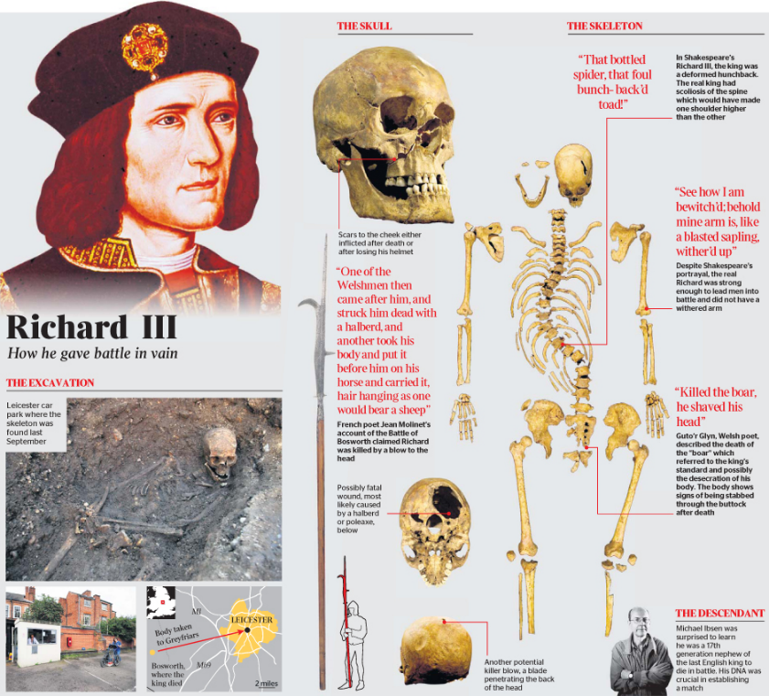
RICHARD III

Leicestershire visitor economy worth £2.4 billion - Visit Leicester
https://www.thearchaeologist.org/blog/the-discovery-of-king-richard-iiis-burial-site
Richard III: How things have changed since we dug up a king
https://www.bbc.co.uk/newsround/32069032

