NEW YORK’S NEW TOWER AES L2
From BBC Learning English - Words in the News / New York's view from the top
Name these high-rise buildings (the Gate of the Orient / the Gherkin / the Freedom Tower / the Twin Towers / the Walkie Talkie)

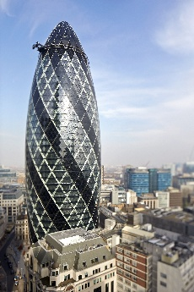
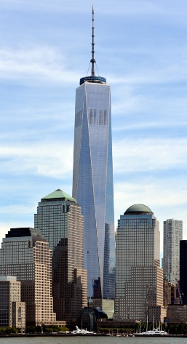
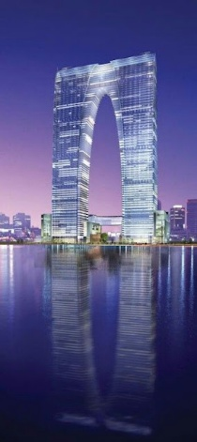
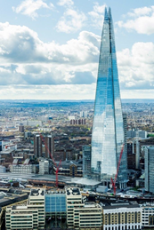
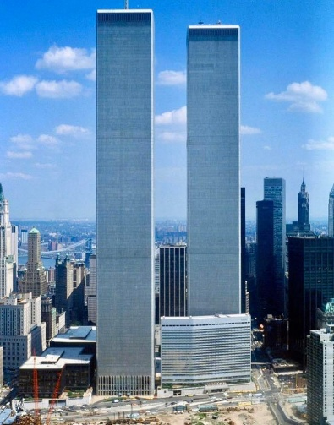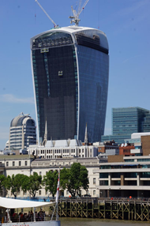
Subject | Verbal group | Clause(s)
- Freedom Tower + New York | be | building + tallest + in+ hemisphere + western
- tower + 100 + floor | now+ be + open | visitor+world+over+all
- skyscraper+new+  600+meter | replace | center+world+trade+tower+two
- New Yorker | still + feel | trauma + attack + terrorist + 2001
- construction+  monument+  landmark | help (someone to....) | NY City + recover

Equivalents to the sentences in the chart :
- No building in the USA, Britain or the EU is taller than the Freedom Tower.
- People from the USA and the rest of the world can now visit it.
- The Twin Towers used to stand where the Freedom Tower is located.
- The 2001 event hasn’t been forgotten by New York’s citizens.
- Building a new tower has helped New Yorkers to feel better and more confident about the future.

