I. AUDIO
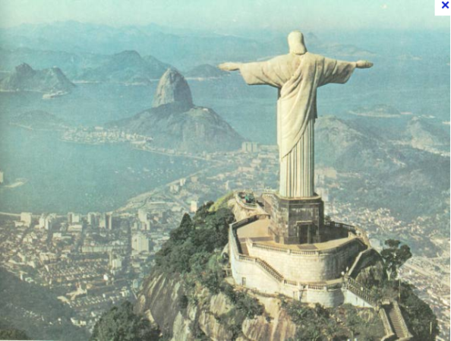a. Prononciation des voyelles : quels mots se prononcent de la même façon ?

“lettre a”
status talk star statue Brazilian

“lettre i”
ironic iconic birthday Christ the Redeemer

“lettre e”
perched inaugurated figure Christ the Redeemer

“lettre o”
torch monument Rio de Janeiro visitors

“lettre u”
monument inaugurated statue status

b.Listen to the report. Which words can you identify?
statue status
ironic iconic
birthday anniversary
mountain hill
torch monument
bought built
tourists visitors

c. Listen again answer as many questions as you can
1. How big is the mountain on which the Statue of “Christ the Redeemer” stands?
………………….
2. What is the name of that mountain?
……………………………..
3. How old was the statue in 2011 (when this report was made)?
…………………………..
4. How tall is the statue?
…………………..
5. What is the statue made of?
…………………………….
6. How long did it take to build the statue?
…………………………
7. Who was the architect?
……………………………….
8. When was it inaugurated?
……………………………..
9. How much did it cost to build it?
…………………………….
10. How many tourists visit the statue every day?
……………………………
11. Why is the statue fragile?
………………………………..

Use these paragraphs to complete and check your answers

In May 1922, the “catholic Circle” of Rio took up a 63 year-old idea, which consisted in building a figure of Christ on a hill overhanging the city and the bay of Rio. Heitor da Silva Costa, a Brazilian civil engineer, won a competition for the construction of the monumental Christ the Saviour statue. In 1923, Da Silva went to France to find a sculptor and met Paul Landowski. After Landowski put forward the statue of Christ with the wide arms, Da Silva Costa accepted and Landowski was appointed as architect.

The 38 meter monument was inaugurated on 12 October 1931 on top of Rio's Mt Corcovado and is considered the largest Art Deco-style sculpture in the world. It is made of reinforced concrete and covered in a mosaic of thousands of triangular stone tiles. It stands on a square stone pedestal base about 26 feet (or 8 metres) high. The Rio Christ is visited by nearly two million people every year and in 2010, it underwent a $4 million (£2.7m) restoration.

A lightning strike has damaged a thumb of Rio de Janeiro's famous Christ the Redeemer statue. The thumb on the right hand of the 38m (125ft) statue was hit during a storm on Thursday night, officials said. Officials from the Archdiocese of Rio, which manages the statue, told Brazilian media that repairs will be made to the statue soon. The National Institute for Space Research (Inpe) declared that the statue is struck by lightning on average between three and five times a year.

TENSES

Find all the verbs in the preterite, in the present simple and in the present perfect.

Make a list of all the irregular verbs.

