 | A(n) | -S | some | several | many / (a) few | much /  (a) little | Countable /  Uncountable/collective | Why ?
Inspector | yes | yes | yes | yes | yes | no | Countable | « ordinary » words
Hygiene
Proof
Intelligence* | no | no | yes | no | no | yes | uncountable | Concepts, abstract notions
Evidence
Money
Offer
Demand
Police
People
Staff | no | no | yes | yes | yes | no | Collective | Groups of people (or animals)
Employee
Fine
Shock
Shrimp
Prawn
Information
News
Media
*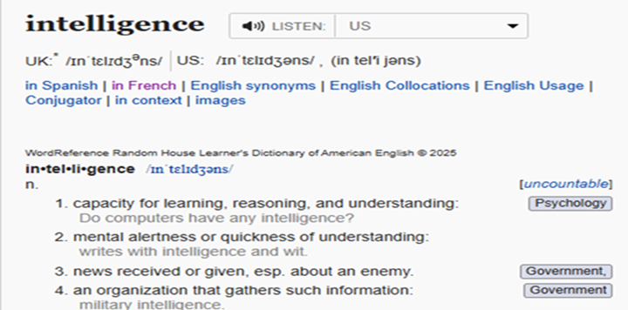* wordreference definition

SUM UP THE COCKROACH STORY
The Mu Brothers are Somerset millionaires who own ……. bars and Chinese restaurants.
When ……. cockroaches were found in ….. plate of king prawns at the Sea Palace, it caused …….. outrage (=shock.)
The Mus’ employees probably spent very …….. time cleaning their refrigerators.
The food hygiene restaurant found ……. evidence (=........ proofs) of ….. cockroach infestation at the Sea Palace.
When the evening paper published the story, there was so ………. demand that ……. newsagents had …… copies left (= a lot of newsagents sold all their copies).
The 1,400 copies which were sold in North Somerset were worth ……. money.
Two mystery men visited as …… newsagents as possible.
They needed …….. pluck (=courage) to buy up to visit Somerset’s newsagents and buy up their copies.
They used ……. stupid pretext to buy up the copies – they claimed they wanted an article on George Best.
……… people remember who George Best is today.
He had gained ……. fame in the 1970s and 1980s as Britain’s most talented football player.
Football careers don’t last ........ . As Best spent ……. money on drinking, dating and gambling when his career was over, the end of his life was very sad.
Very …… local people around Weston Super Mare could read about the Sea Palace scandal. (=there was very ……… information/……. news on this scandal)
The Mu brothers probably lost ……. of their reputation in this scandal.
They were forced to spend …….. money in fines, legal costs and repairs after they were condemned at Flax Bourton Magistrates Court.
….. Sea Palace staff lost their jobs after the managers were fined.
The Mus have been condemned …….. times for ignoring hygiene and safety regulations.
They probably don’t care ...... about their fines. They can pay as ……. fines as they want, since they are millionaires!

