VOCABULARY SHEET L2AES 2025 S 4
Field of study : censorship, incitement to hate, book sales, cancel culture
pictures related to the documents
Censorship
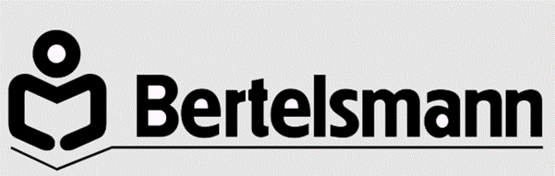
To evade censorship
To censor a book
Internet bookstores
To ban booksellers from selling a book
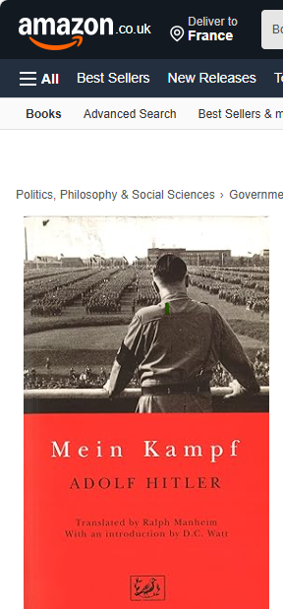
To bar people from publishing a book
To withdraw a book from the stores

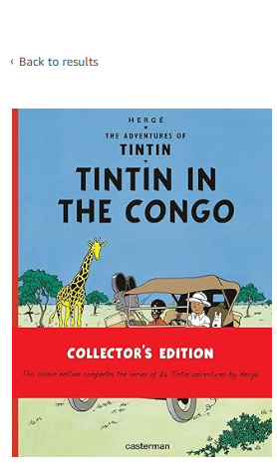
To pull a book from the Net
To curtail the freedom of speech

To spread hate
Widespread racist mentalities
Incitement to race hate
To incite to race hate
Colonialist prejudice
Antisemitic literature
Rant
Fake news
Racist propaganda
Racist content
A gollywog

A frivolous lawsuit
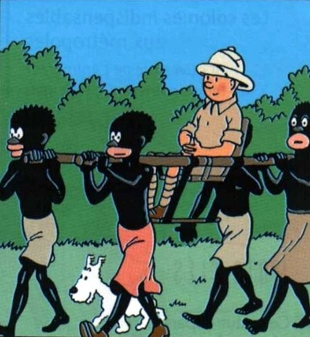
To sentence a defendant for a crime
A sentence
To charge a defendant with incitement to hate
To convict a defendant on a charge
A conviction
A fine
To fine
A compensation request
To sue someone in compensation
To file a lawsuit in damages
Cancel culture
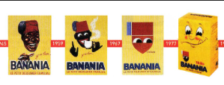
A publishing house
A bookshop
An online bookstore
To purchase a book online
To be on shelf
To be off shelf
To put a book on sale
To release a book
Copyright
The Banania brand’s logo
(from the 1930s until today)
To fall in the public domain
To sell the book with a warning

QUESTIONS (20 mn--pairwork, give back your paper or mail it at jean-yves.michel@univ-lorraine.fr)

What products do Casterman and Bertelsman sell ?

What was Hitler’s purpose when he wrote Mein Kampf in the 1920s?

Why is Tintin in the Congo Hergé’s most controversial album ?

Why has Mein Kampf’s Kindle version been pulled from the Amazon website ?

How has the Banania logo evolved since the 1930s ?

What could happen if the Banania brand decided to restore its original logo ?

