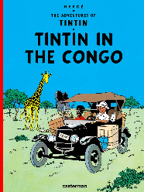
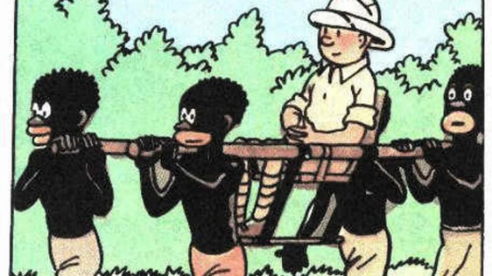
Tintin book on trial
28 April 2010
(Listening comprehension)
- Synonyms
- Preconceptions about ethnic groups ; set racist representations | to publish tu ˈpʌblɪʃ
- Animals which can’t be tamed (like lions, leopards, elephants, etc.) | a gollywog ə ˈɡɒlɪˌwɒɡ
- A citizen | a swashbuckler ə ˈswɒʃbʌklə
- Black Africans, as they were represented in colonial caricatures | outrage ˈaʊtreɪdʒ
- To wow | to regret tu rɪˈɡret
- The heart of darkness (for 19th Century colonisers) | prejudices ˈpredʒʊdɪsɪz
- To release ; to put on the market | a ginger quiff ə ˈdʒɪndʒə kwɪf
- A label which indicates something important about a product (like safety regulations) | remote rɪˈməʊt
- To criticise | wildlife ˈwaɪldlaɪf
- An adventurer (like Jack Sparrow, Lara Croft or Tintin) | a warning ə ˈwɔːnɪŋ
- To pull an item from the shops ; to make it illegal | a national ə ˈnæʃnəl
- Red hair (like Tintin) | to ban tu bæn
- Shock, scandal | to fascinate tu ˈfæsɪneɪt
- Distant ; far away | to be critical tu bi ˈkrɪtɪkl̩
- To be sorry about what youd did ; to wish you hadn’t done something | deepest darkest Africa ˈdiːpɪst ˈdɑːkɪst ˈæfrɪkə

B) Use some of these words to answer the questions. Play the dialogue with your partner.
Q : Why is Tintin so famous ? A : The famous .................. of Tintin has ............ fans for decades.
Q : How old is Tintin in the Congo? A : The book was........................... in the early 1930s and it is Herge’s second album.
Q : What happens in Tintin in the Congo ? A : Tintin and Snowy are ................ who hire a local guide ; they visit ................... villages and encounter ................... . Tintin even kills a rhino !
Q. Why is the book so controversial ? A. Actually, it is a racist book, because the Africans are represented as .......................... . This reflects the ....................... of the 1930s, and today, it can cause ............................ .
Q. Can Tintin in the Congo still be bought legally ? Yes, it’s still on the shelves, except in the USA. However, a Congolese ........... living in Belgium asked the courts ................... the book in 2007.
C. Listening comprehension
C1. Listen and identify the words
C2. Listen and fill in the gaps
The famous .................. of Tintin has ............ fans for decades. Travelling the world on wild adventures with his dog Snowy, the comic books contained elements of fantasy, mystery, even political thrillers. And political is exactly what this episode has become.
Originally ........................... in the early 1930s, Tintin in the Congo follows the intrepid boy reporter to ....................., in what was seen as ........................... - at the time a Belgian colony. There the ................ hire a local guide, visit ................... villages, even encounter .................... . So far so normal for a ...................... . But it's the language and imagery used in the comic which has caused .................. in those ............... of it.
The guide looks like a ..................... – pitch black complexion, ............... and and plump red lips. And the views espoused are ................. and ....................... . The Belgian writer and illustrator, Hergé who wrote them, later said he ................ writing it - a youthful bit of fun which reflected ................... of the time.
But that’s not how Bienvenue Mbutu sees it. He’s a Congolese ........... living in ..................., and he's asking the courts ................... the book, although he says he would be satisfied if it was sold with ...................... about its content.

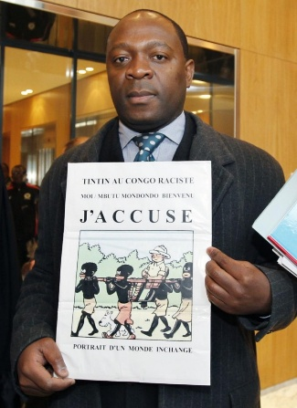
D. THE VERDICT (PAIRWORK)
TRANSLATE ALL THE WORDS IN ITALICS ; WRITE SENTENCES TO ANSWER
- Did Bienvenue Mbutu get what he wanted ?
- How did the court justify its verdict ?
- What was his response to the verdict ?
- How do booksellers protect their customers against the racist content of the book ?
- What effect did the controversy have on the book’s sales ?

A Belgian court has rejected an application to ban a controversial Tintin book over claims it breaches racism laws. It said it did not believe the 1946 edition of Tintin in the Congo was intended to incite racial hatred.
Congolese campaigner Bienvenu Mbutu Mondondo launched legal proceedings in 2007 to get the book banned, saying its portrayal of Africans was racist. Mr Mbutu's lawyer said he planned to appeal against the decision.
Written in the late 1920s, Tintin in the Congo was the second book Herge produced featuring his young reporter hero. It was first serialised from 1930 to 31 and was then reissued in 1946. The book tells of Tintin's escapades in the former Belgian colony and includes encounters with diamond smugglers, big game hunters and wild animals.
Tintin in the Congo has always attracted criticism, and Herge said later that he was not happy with the work.
The Belgian court said it was created at a time when colonial ideas were prevalent. "It is clear that neither the story, nor the fact that it has been put on sale, has a goal to... create an intimidating, hostile, degrading or humiliating environment," the court said in its judgment.
UK editions of the book, published in English in 1991, are generally found beside more adult literature and inform readers the content could cause offence.
In July 2007, British human rights lawyer David Enright complained to the United Kingdom's Commission for Racial Equality (CRE) that the book was sold in the children's section of Borders bookshop.
Publisher Egmont UK also responded to racism concerns by placing a protective band around the book with a warning about its content and writing an introduction describing its historical context.
The media controversy increased interest in the book, and Borders reported that its sales of Tintin in the Congo had been boosted 4,000%, while it also rose to eighth on the Amazon.com bestseller list. https://www.bbc.com/news/entertainment-arts-17014127

