Belgian robbers asked to come back - and arrested on their return
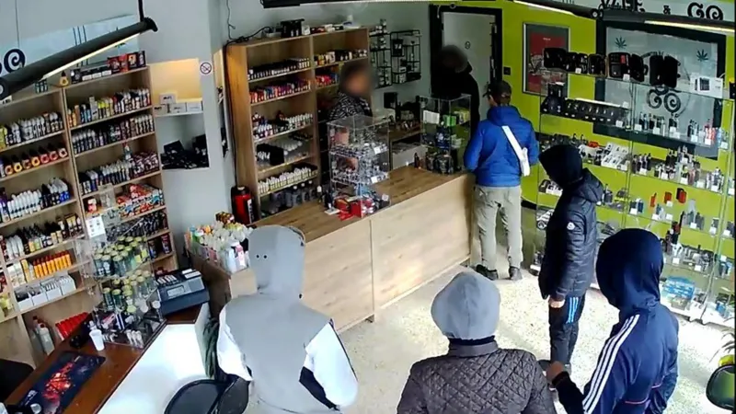
BBC News 23 October 2018
A gang of robbers walk into a shop. The owner asks them to come back later when he has more money, and when they do...
It feels like the makings of a joke, but for a Belgian e-cigarette shop owner this was a frightening reality.
Six people entered Didier's shop in the suburbs of Charleroi in daylight with the intent to rob him.
The salesman told the group to return at the end of the day, when he could give them more money. In the end though, he got them arrested instead.
"It's like it was a comedy," he told the BBC over the phone. "They're being called the worst robbers in Belgium."
The shop owner said that over the course of 14 long minutes, he tried to befriend the thieves.
"They were pushing and shoving but I didn't give them a thing,” Didier said. I said if they came back later, I would have 2,000 or 3,000 euros."
The group bought his bluff, and left.
"When I called the police, they didn't believe they would come back."
But back they did come at 17:30, an hour before the vape shop's closing time. Didier told local media he saw one of the robbers at the door and told them it still was not end of business.
When the men returned a third time, at 18:30, the police were waiting at the back of the shop ready to catch them.
Five males were arrested, including a minor.

TASKS
Listen to the audioclip and find as much information about the robbery as you can.
or you can begin with doing exercises 2, 3, 4 and listen to get more info or check what you found.
- AUDIOCLIP: Describe:
Who? / What happened? / Where? / When?
How it happened / Why it happened
- TEXT: Make a list of difficult or unknown words (ex “salesman”, “suburbs”, “befriend”, “shoving”, “bluff”), then look up these words at wordreference.com

- Make a list of difficult phrases (ex : “he got them arrested”) and look them up at linguee.fr

- Sum up what happened in a timeline (first….next…. then… eventually….)

- Explain why this robbery is unusual in a few sentences.
- NET SEARCH : Compare this story to other robbery stories : which one(s) is/are similar?
- Chilli powder foils armed shop robbers
- Speedboat pair steal Sweden crown jewels
- 'Proud of Grandad for tackling robbers'
- (.....)
(You might have to look up phrases like “être différent de”, “ressembler à”, “alors que”, “de même que”…)

GRAMMAR: Comparing the use of the Past Simple (Preterite) and Past Continuous to narrate a story.
1. Identify all the examples of the Past Simple used within the story. Remember that regular verbs end in -ed but there are many common irregular verbs!
2. Identify two examples of the Past Continuous in the text: was / were + verb (+ing)
3. Read through the following grammar rules then complete the activity which follows:
Past Simple: Completed actions which happened at a specific time in the past (although the specific time isn’t always stated).
(+) subject + past form – He took the bus to the city centre.
(-) subject + did not + infinitive – I didn’t go to the party last night.
(?) (question word) + did (not) + subject + infinitive – Why didn’t you come swimming with us?

Past Continuous: Used:
- to describe a continued action happening in the past or an action that was in progress at a specific time in the past (e.g. I was reading at 8pm);
- to talk about two actions that were happening at the same time in the past (I was cooking while he was watching tv);
- to describe a longer action that was interrupted by a shorter action (I was walking when I saw her);
- to set the background / a scene in a story (The sun was shining and the birds were singing);
- to emphasise the duration of an action in the past (They were playing for hours);
- in indirect speech when we report what someone was doing at a specific time in the past (She said she was longing to see him).
(+) subject + was/were + verb -ing – I was playing tennis yesterday.
(-) subject + was/were + not + verb -ing – He wasn’t looking at you.
(?) (question word) + was/were (‘nt) + subject + verb -ing – Why were they running away?

Decide if you use the Past Simple (PS) or Past Continuous (PC) in these situations (Taken from Teach This):
a. You want to emphasize that an action took some time.
b. You want to talk about a state or situation that was true in the past.
c. You want to emphasize something happened again and again over time.
d. You want to emphasize change or growth over time.
e. You want to talk about a one-time completed action or event. The duration isn't important.
f. You want to talk about a relatively long action that was ongoing at a particular time.
g. You want to talk about a repeated, completed action or event. The duration isn't important.
h. You want to talk about a relatively long action that was interrupted by a shorter one.
i. You want to talk about a relatively short action or event that happened during a longer one.
j. You want to talk about a plan that would have been completed in the past but was changed.

4. Decide which of these tenses is correct (PS or PC) in each of the following sentences about the story:
a) The robbers entered / were entering the shop as Didier, the owner, served / was serving his customers.
b) While one robber watched / was watching the door, the others looked / were looking around the shop.
c) Didier tried / was trying to sound friendly but the situation suddenly changed / was changing.
d) However, Didier stayed / was staying calm even while the gang argued / were arguing amongst themselves.
e) The robbers stood / were standing at the counter when Didier made / was making his suggestion.
f) Everyone expected / was expecting trouble, but surprisingly the situation ended / was ending without violence.
g) The police told / were telling Didier there was no chance the robbers would come back.
h) The police waited / were waiting nearby when the men returned / were returning at 18:30.
i) The police arrested / were arresting the robbers as they robbed / were robbing the shop again.

