A. WHO WAS NED KELLY?
Biography (take notes on Kelly’s life and death)
https://www.slv.vic.gov.au/search-discover/explore-collections-theme/australian-history/ned-kelly/ned-kelly-fact-sheet
https://youtu.be/jhAllnWPdcU
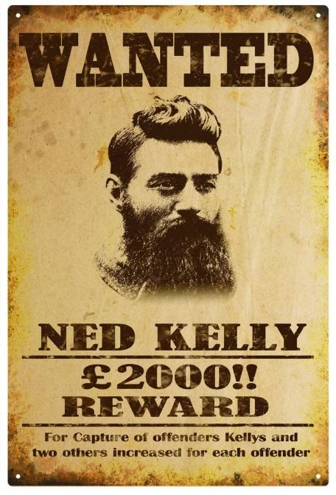
Johnny Cash’s tribute to Ned Kelly : an « outlaw ballad »
(https://youtu.be/2LH7FXf66KU)
« In .......................... , a bandit or an outlaw was called a ..........................
One of .......................... 's most infamous .......................... s, was a man named Ned Kelly

Ned Kelly was a wild young ..........................
Out of ……….. he rode with his brother Dan
He loved his people and he loved his freedom
And he loved to ride the wide open …………..
Ned Kelly was a victim of the …………
That came when his land was a sprout and seed
And the wrongs he did were multiplied in …………….
With young .......................... growing like a weed

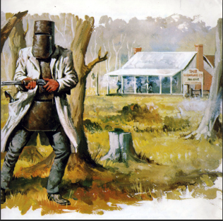
« Ned Kelly took the ..........................
Ned Kelly won the ..........................
Ned Kelly brought the ..........................
And then Ned Kelly hanged

« Well, he hid out in the ……….. and in the forest
And he loved to hear the wind blow in the ………….
While the men behind the badge were coming for him
Ned said they'll never bring me to my …………..
But everything will ……… and run in cycles
And Ned knew that his day was at an ………
He made a suit of armour out of ploughshares
But Ned was brought down by the trooper's …………

« Ned Kelly took the ..........................
Ned Kelly won the ..........................
Ned Kelly brought the ..........................
And then Ned Kelly hanged

B1. USE THESE WORDS AND PHRASES TO ANSWER THE QUESTIONS

What sort of life did Kelly live ? (19th Century / bankrobber / to rob banks / to lead a bunch of outlaws)
Where did he live and why? (the “outback” / a deserted area / to allow (someone to …) to flee from the police / to store weapons / to conceal stolen property)
What did his reputation rely on ? (a Robin Hood figure / to steal from the rich / to give to the poor / to resist the police)
Eventually, the police found him in a farm. (Glenrowan / to wear armour / to protect oneself / to be surrounded (by …)/ to besiege a farm) / to make a last stand / to surrender
Then, his case was examined by a court and he was declared guilty. (to be jailed / to be sentenced (to…) / death menalty / to be hanged)
There is a mystery about his death. (a grave / unknown // to be buried / to be lost / skeleton)
B2. To which of these movie characters could Ned Kelly be compared to ? Explain why.
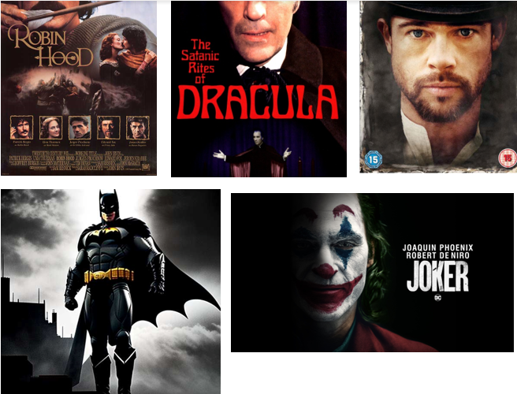
C. Use the brochure on the next page to add details
The Ned Kelly park is located in a small city, in the outback. However, this city is famous.
It isn’t a cheap attraction. (AUS $1 = E0.61 or £0.52)
It has been operated for many years.
Bob Hempel invested a lot of money in this park.
It has a got a show which doesn’t need any actors.
This is a Western-style show.
The show is free for young children.
However, some of them could get bored…. or even frightened !
A flier from Bob Hempel’s Ned Kelly Theme Park
Bob Hempel presents:

NED KELLY'S LAST STAND
at the GLENROWAN TOURIST CENTER
THEME PARK

30th Anniversary of this 8.5 million dollar extravaganza

This interactive, theatrical production is fully air conditioned, runs for 40 minutes, and can seat up to 80 people at any one time.

THIS IS NOT A PICTURE THEATRE (It is a THEME PARK)

To anyone who ever dreamed.
Don't tell me that at sometime in your life you haven't fantasized about going back into history and participating in an historical event.

Well here is your chance to live that dream.

For through the brilliance of animation and computerised robots, you will be transferred back in time, over 100 years, to witness the events that led up to the capture of the Kelly Gang.
Starting as hostages in the Hotel, and then onto gunfights - burning buildings - a decent hanging, and finishing in our magnificent painting gallery.

The show is educational, historically correct and entertaining.

Runs for 40 minutes every half hour (seperate rooms) from 9.30am to 4.30pm daily.
Only for people who want to enjoy themselves.

Contact: 41 Gladstone St. Glenrowan Vic 3675
Ph: (03) 5766 2367 - Fax: (03) 5766 2952

To help you find us: Glenrowan is 2km off the Hume Freeeway between Benalla and Wangaratta ; Situated in the oregon building next door to the overpass (2 1/2 Hour Drive from Melbourne)

THE PARK’S « COMPUTERISED ANIMATED THEATRE » : PRICES AND CONDITIONS
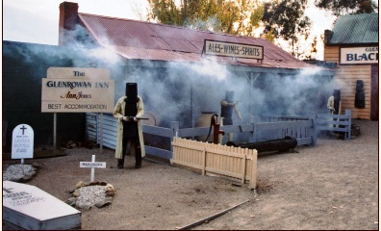

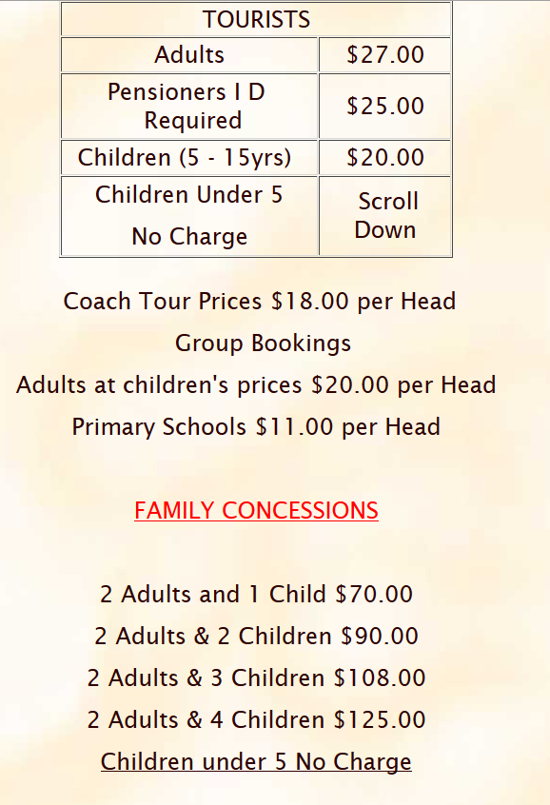

CONCLUSION : Is the Ned Kelly park actually worth visiting?
Visit https://www.nedkellyunmasked.com/2023/10/the-glenrowan-kelly-hub-reviewed/

