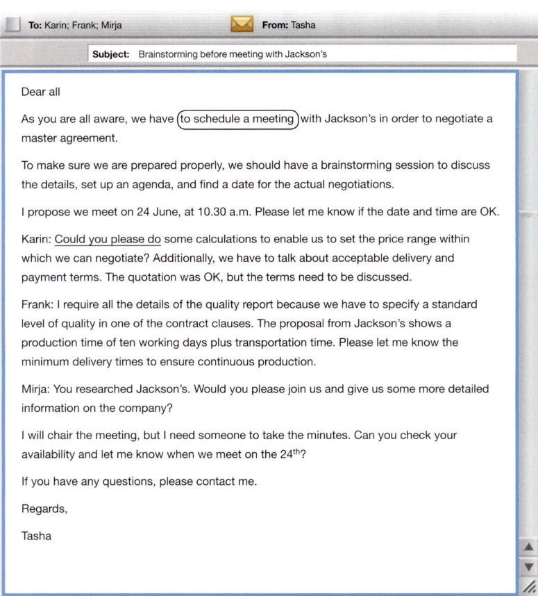
Exercise 1: Now answer the following questions.

1. When does Tasha want to meet her team?
24th of June at 10:30 am

2 Who should be at the brainstorming meeting?
Tasha, Karin, Frank, Mirja

3 Why are they meeting with Jackson's?
To negotiate the master agreement

4 What should Frank bring to the meeting?
A quality report

5 How long does it take to make the product?
10 working days

Exercise 2: Which phrases are used to ask for information and which ones are used to plan a meeting?

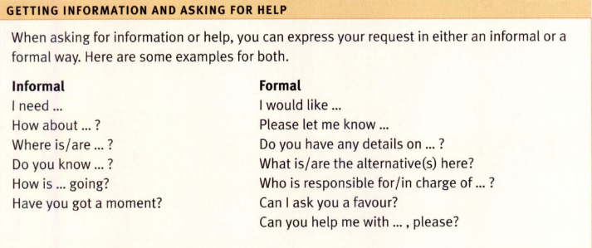

To ask for information | To plan a meeting
Can you help me with…please | Please let me know…
I need… | I need
Where is/are | How about…
Can I ask you a favour? | I would like…
Do you know?
Have you got a moment?
How is…going
How about…
I would like…

Exercise 3: Complete the tables.

Verb | Noun
To negotiate | Negotiation
To propose | Proposal / Proposition
To arrange | Arrangement
To discuss | Discussion
To prepare | Preparation
To calculate | Calculation
To deliver | Delivery
To pay | Payment

Verb | Noun
To quote | Quotation / Quote
To specify | Specification
To produce | Production
To transport | Transportation
To chair | Chair
To inform | Information
To produce | Production
To meet | Meeting

