A1) Pronunciation : guess what these phonetic transcriptions mean

‘mæntʃestə ju/nɑitid

/fʊtbɔːl mændʒə

/fʊtbɔːl steɪdɪəm

ɪɡ/zekjʊtɪv

brɔ:dka:stiŋ /revənju:

/stɒk ɪkˈstʃeɪndʒ

/ʃɛəz

/grəʊθ

/ˈspɒnsəʃɪp diːlz

A2) Define these phrases in a sentence

Manchester United : ……………………….

A football trophy : ………………………….

A Manchester United executive : …………………………

Sponsorship deals : ………….

Deloitte inc : ………………………………..…………………………………

The New York Stock Exchange : ………………………………………….

B) Choose an appropriate equivalents for the words in italics
- Manchester United has reported a sharp rise in profits and revenue despite a disappointing season on the pitch.
- For the three months to the end of March, profits were £11m, up from £3.6m a year ago. The club posted record revenues of £115.5m for the period.
- Commercial, broadcasting and match day revenues were all up on last year. The club is expected to appoint Holland manager Louis van Gaal to replace David Moyes, who was sacked last month, as manager for next season.
- Club executive vice chairman Ed Woodward said:
- "We once again generated record revenues as all of our businesses delivered impressive year-over-year growth.
- "This puts us in a healthy position to continue to invest in the squad. Everyone at the club is working hard to ensure the team is back challenging for the title and trophies next season".
- Commercial revenue rose almost 20% to £42.8m, largely due to an increase in sponsorship - the club signed deals with drinks company Aperol and with Eurofood in Southeast Asia.
- Broadcasting revenue was up 64% at £35.6m.
- Meanwhile, match day revenue was up slightly at £37.1m.
- Overall debt fell by £16m to £351.7m
- According to the most recent Deloitte Football Money League, Manchester United is the fourth highest-earning club in world football.
- Shares in the club were floated on the New York Stock Exchange in 2012. BBC News 15 May 2014

Manchester United will probably take on (or recruit) a new coach for the team.
Manchester United won too few matches.
Manchester United’s “number 2” made a public statement
only three clubs make more money than Manchester United in the world.
Manchester United published huge, exceptional earnings
The earnings obtained from the football matches which were shown on TV increased a lot.
all the club’s activities brought in large yearly profits
The club’s profits from the match tickets sold every day increased a little.
our financial results will enable us to keep spending money to develop our team
Manchester United’s increase in profits is largely due to the companies which have advertising contracts with the club.

Manchester United entered Wall Street a few years ago.
Manchester United owes less money to its creditors.

C) PAIRWORK : Use the statistics to make an assessment of Manchester United’s 2013 results (write a paragraph and report to the group)

C1. GRAMMAR
Useful words with preposisions like “from”, “to”, “at” and “in” (cf exercise B)
+ preterit/ present perfect
les bénéfices ont augmenté de …% jusqu’à un total de ….. en 2012
ils ont baissé de ….. jusqu’à un total de …..
ils ont monté légèrement jusqu’à ….
ils sont en hausse de … par rapport à l’année dernière
ils s’élevent à un montant de…..
ils vont probablement augmenter d’un facteur de ….%
C2. PLAN
use the text and the STATISTICS on the next page (From the Deloitte website ; 2013)

- Manchester United : a football club or a company?
- The club’s football results in the 2010s
- The club’s financial situation in the 2010s
- MU’s revenue profile (= where the profits come from)
- The Club’s debt (2005-2013)
- conclusion : where does Manchester United’s revenue come from?

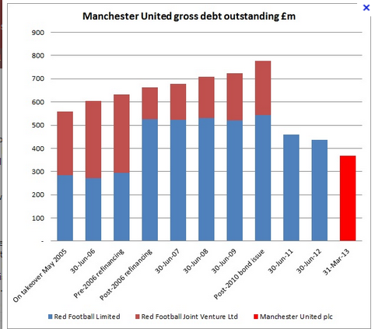

(missing words : takeover May 2005 / 2006 refinancing / 2010 bond issue)
