A. The Colosseum restoration scheme (video/audio)
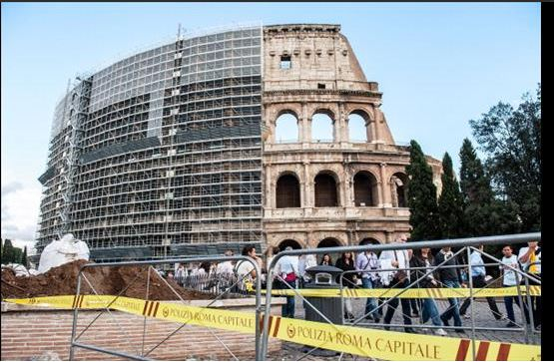

A1) Complete these passages from the audio clip

“and I’m going straight …………………, to see the Colosseum ……………………………………….…… “

“It’s pretty low-tech, ………………………...………………. . After all, they don’t want it ………………………………………………………………………...”

“It’s about making the Colosseum …………………………., but also …………………….. .”

“The outside will be finished ……………….., then work starts on the ………………….., along with …………………………. “

“So on this side the view is pretty stunning ………………., but …………………………………”

“It’s been paid for with …………………………………………..Todd’s, and in Rome it’s fashionable for ………………………..…….. to ……………………………”

A2) QUESTIONS (listen again and take notes)

How many people visit the Colosseum every year ?
Very simple materials are used in the restoration. Which ones?
Why is this restoration urgent?
How tall are the ruins of the Colosseum?
When will the outside restoration be finished?
How much does this restoration project cost?
Who is footing the bill (=who is paying)?

Next page : TEXT

Roman Colosseum Restoration Begins In Rome
After almost three years of debate and delay, restoration work on Rome's ancient Colosseum has begun. Scaffolding began to obscures part of the immense structure in the heart of the Italian capital more than a month ago, but a ceremony this week marked the official start of work.
Diego Della Valle, founder and chief executive of the Italian fashion and luxury design brand Tod's, stumped up the cash to restore what is considered one of the world's most iconic monuments, and a lasting symbol of Imperial Rome. He's made 25 million euros ($33 million) available for the project to rejuvenate the structure, which is also known as the Flavian Amphitheatre -- the largest in the world.
Della Valle, who first announced his donation in 2010, lamented the years of delay at a news conference this week announcing the beginning of restoration work. Legal action brought by consumer associations and trade unions was largely behind the three-year wait.
Della Valle said many of Italy's most iconic tourist attractions "are literally falling apart," and said the rapport between public institutions and the private sector leaves much to be desired. He said investors are scared away from backing public projects by the sheer amount of government red tape involved, but warned the state could no longer be expected to maintain its immense cultural wealth without additional private funding.

Source : CBS NEWS, Dec 5, 2013 (http://archive.digtriad.com/news/article/308070/1/Roman-Colosseum-Restoration-Begins-In-Rome)
B. Find words from the text which correspond to these ones :
to give money to
devices which allow workers to work safely aat an important height (for ex. 10 meters high)
lawsuits
organisations which defend the rights of workers and employees
to make sure that a building is in a good state of repair
to be able to
to be afraid of
to be under the necessary level ; not to be sufficient
cultural or historical heritage
the huge quantity of official documents required by public authorities
to give or grant large sum of money
to stop doing something (adverb)
to restore a monument
= « if there isn’t any »
to financially support, to fund
more financial support from the business sector
world famous
to be ruined or dilapidated

C. Pairwork : QUESTIONS (use the words in B to write down your answers)
Who is Mr Della Valle ? What did he do for the Colosseum ?
What does he think about the funding of Italian restoration projects ?
Does he think that restoring these monuments is important ?

