A1. First audioclip -- the words (plus others)

(un)affordable prices
“a nation of home-owners”
a Monopoly-like market
a mortgage
a property
a realtor
an (un)sustainable growth
foreign investors
on sale / on offer
outrageous prices
prospective buyers
real estate
the average buyer
the City
the Conservatives
the entering price
to be pushed back to the suburbs
to bid (for a property) / a bidder
to sell / purchase a house for £200,000
to soar / to skyrocket

Complete (or modify) the sentences you heard
The market is soaring.

Bidders face prices.

Buyers are pushed to the suburbs.

Properties are unaffordable.

The market functions like a game.

The growth is unsustainable.

A2. Choose appropriate answers
Which British PM wanted Britain to become “a nation of home owners” in the 1980s?
(1 answer)
- Margaret Thatcher / 2. Ronald Reagan / 3. Tony Blair / 4. David Cameron
5. Theresa May / 6. Boris Johnson

Describe the mechanisms and consequences of that government policy
(probably right or certainly right :
probably wrong or completely wrong : )

IMPACT OF THE POLICY ON BANKS

(probably right or certainly right : 5 sentences
probably wrong or completely wrong : 1 sentence)

- In the 1980s, British banks were allowed to offer mortgage loans at very low interest rates.
- More and more British people borrowed money from banks to purchase property.
- Eventually, that policy built a financial bubble and led to a real estate market crash around 2008.
- Since the 2008 crisis, the British Parliament has reinforced real estate legislation.
- The policy has boosted speculation on the London real estate market.
- It has facilitated money laundering in “Londongrad.”

IMPACT OF THE POLICY ON HOUSE BUYERS AND HOME OWNERS
(probably right or certainly right : 3 sentences
probably wrong or completely wrong : 3 sentences)

- Lizz Truss was evicted from her home in 2022, for not paying back her mortgage.
- Many British people have subscribed to mortgage loans since the 1980s.
- People who sold homes in Central London or in the City have lost a lot of money.
- Middle-class house buyers are being excluded from the London property market.
- Market pressure is so high in that “Monopoly game” that Londoners purchase properties without visiting them.
- The London property market can keep growing for years.

BBC clip--Comprehension

B1. (From the beginning to 10:30)
London buyers and the Central London real estate market

- Find out what these figures correspond to (in report order)

- Compare your answers with your neighbours’.

£250,000
- £100,000 in London even exists
- £125,000
- £280,000
- 48 hours
- £805,000
- has doubled / around half to foreign investors
- £8bn
- 800 homes sold to Malaysian investors
- in prime Central London, 85%wly built property was sold to intrnational buyers
- 25 years ago
- £60,000
- three quarters of a million
- £530 every single week for a quarter of a century
- up to £150,000
- to go for £150,000 to £200,000
- a full-blown £20,000 difference fro

B2. Explain what you found by answering the questions

B2. PAIRWORK – change the tenses when necessary

- London property prices rise for about 20 years.
- When a house is put on sale in Central London, potential buyers rush to purchase it.
- The Londoners who buy Central London or City property twenty years ago can make a huge return on investment.
- However, the Londoners who currently look for property pay huge amounts.
- Central London and City properties are unaffordable for middle class Londoners.
- Actually, cash-rich Russian and Chinese investors capture the market.
- Urban planning is often attacked for being slow, out of touch, and market hampering.
- Since the 2010s, the public authorities largely withdraw from the provision of housing and encourage private development.
- This boosts house prices instead of providing citizens with affordable properties.
- The price of London rises continuously from 1995 to 2020 and peaks at £800,000 in 2020, but it falls to £600,000 since then.
- Does it mean that the London property market becomes affordable for middle class buyers?
- As Londoners earn £65,481 per year on average, a mortgage represents about ten years of annual pay.
- But London life is expensive, so that the total refund probably takes thirty years.
- And the pressure from speculators doesn’t disappear.

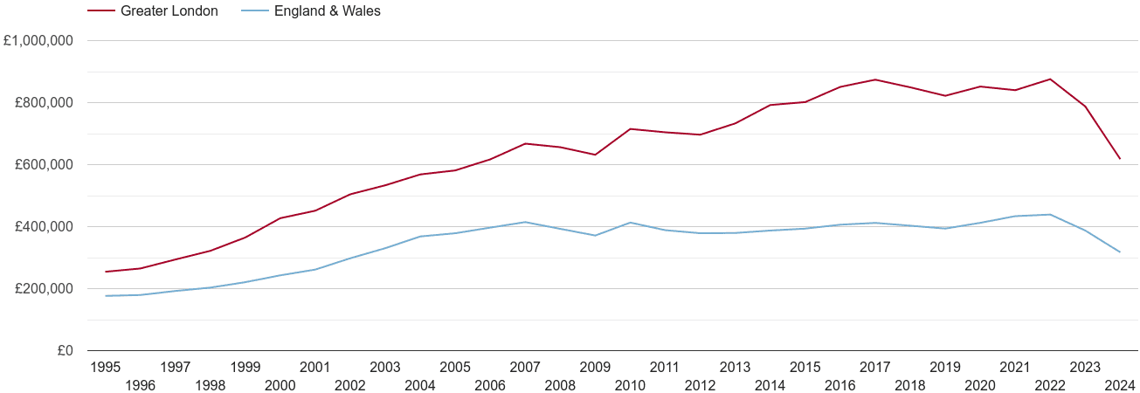

Present simple : FACT, (universal) TRUTH
Water boils at 100°C, which represents about 212 Fahrenheit degrees.

Present continuous : we have a problem and we must act NOW!
It’s raining. Open your umbrella!

Present perfect : ASSESSMENT OR ESTIMATE (result of a past situation or action)
He hasn’t opened his umbrella and he has walked in the rain. No wonder he’s sick now.

Present perfect continuous (« long time » + assessment)
It has been raining for two hours and you still haven’t opened your umbrella !

Preterite : PAST EVENT
He fell sick yesterday because he didn’t open his umbrella when he walked in the rain..

