White collar crime : money laundering and Ponzi schemes

sources :
investopedia.com (https://www.investopedia.com/terms/m/moneylaundering.asp)
https://www.sanctionscanner.com/blog/most-well-known-aml-regulators-764
the guardian https://www.theguardian.com/business/2018/sep/20/danske-bank-money-laundering-is-biggest-scandal-in-europe-european-commission
history of US anti money laundering legislation
https://www.fincen.gov/history-anti-money-laundering-laws
Chainalysis. “Crypto Money Laundering: Four Exchange Deposit Addresses Received Over $1 Billion in Illicit Funds in 2022.” https://www.chainalysis.com/blog/crypto-money-laundering-2022/
IMF website : Financial Crimes Hurt Economies and Must be Better Understood and Curbed
(https://www.imf.org/en/Blogs/Articles/2023/12/07/financial-crimes-hurt-economies-and-must-be-better-understood-and-curbed)
Greece’s 2004 Olympic games scandal (https://www.occrp.org/en/news/ex-greek-minister-sentenced-for-money-laundering-in-siemens-scandal)
Richard Nixon, the Watergate Scandal and money laundering https://www.nytimes.com/1974/05/17/archives/an-explanation-how-money-that-financed-watergate-was-raised-and.html
FBI archives
https://archives.fbi.gov/archives/newyork/press-releases/2009/nyfo031009.htm
Thierry Magon de Villahuchet, Madoff’s first casualty
https://abcnews.go.com/Business/story?id=6532699&page=1
Charles Ponzi
https://www.fraud-magazine.com/article.aspx?id=4294970026

Youtube (The Economist) :
“Londongrad” https://www.youtube.com/watch?v=IcT-byRlKrY
“Danske Bank scandal” https://www.youtube.com/watch?v=n219ECvW70U

KEYWORDS

white-collar crime
legit cash / dodgy money
to deposit money on an account / to withdraw money from an account
to turn illegal money into legit cash
layering / placement / integration
syndicates
fronts / shell companies / fiscal havens
fraudulent schemes
smartphone P2P (=peer to peer) transfers
terrorism funding
AML (=anti-money laundering) policies
GDP (=gross domestic product)
FCA (Financial Conduct Authority ; UK)
OFAC (Office of Foreign Assets Control ; USA)
CTF (counter terrorism financing)
traceability
banknotes (=bills) / registration numbers
monitoring / compliance (to monitor / to comply with)

investment advisor (from investopedia.com)
financial professionals that make investment recommendations
they also conduct security analysis in exchange for a fee.

Regulation In the U.S:
they are required to register at the state level
they also need to register with the SEC if they manage $100 million or more in client assets.

discretionary authority over their clients’ assets
they are required to uphold standards of fiduciary responsibility.

THIS COURSE WILL BE PART OF YOUR TEST IN JANUARY
SO DON’T FORGET TO TAKE NOTES.

PLAN

- Definition

- Extent and dangers

- How to control money laundering

- Example : the Danske Bank scandal

- Definition

Why do criminals launder money ?  Money launderers convert dirty money into clean money ...............  Why has it become easier to launder money ?  Online banking and cryptocurrencies allow criminals ......................................  Why is it important to tackle money laudering on a global scale ?  As money laudering funds terrorism, international agencies must ..............  What action has the financial industry taken to combat money laundering ?  The financial industry has set up its own set of strict anti-money laundering (AML) measures ......................... | to transfer and withdraw money without being detected  hunt down money launderers and bring them to justice  to achieve a better and more coordinated monitoring  by making the dirty money untraceable  to carry out cash transactions without being identified  to make laundered money virtually untraceable  find out and punish as many money launderers as possible

How money laundering functions

Money laundering can be divided into three steps:

- Placement: the “dirty money” is injected into the legitimate financial system.

- Layering: the funds are « cleared » and « washed »
The source of the money is concealed through a series of transactions and bookkeeping tricks like :

“smurfing”—breaking up large transactions into smaller ones to dodge reporting limits ($10,000 in the US).

“Mules” or cash smugglers: Cash is smuggled across borders and deposited into foreign accounts

Buying and Selling: Using cash for quick turnaround investment in assets such as real estate, cars, and boats
“fronts” : buying or investing into small businesses like restaurants

“shell companies” – corporations without active business operations, set up
to invest dirty money in “tax havens” (low-tax and low-control areas).

Investing in commodities: Using gems and gold that can be moved easily to other jurisdictions

Gambling: Using casino transactions to launder money

- Integration: generating “legit cash”
= Acquiring wealth generated from the illicit funds’ transactions
Laundered money is disbursed from « legitimate » accounts.

Historical background

Where does the phrase « money laundering » come from ?
LEGEND : Al Capone invented money laundering
1930s : Prohibition
= nationwide constitutional ban on the production, importation, transportation, and sale of alcoholic beverages
Capone made a fortune from trading in illegal alcohol.
He is supposed to have used coin operated launderettes to launder the proceeds of his crime.
..... However, Capone never used any landerettes to launder money.


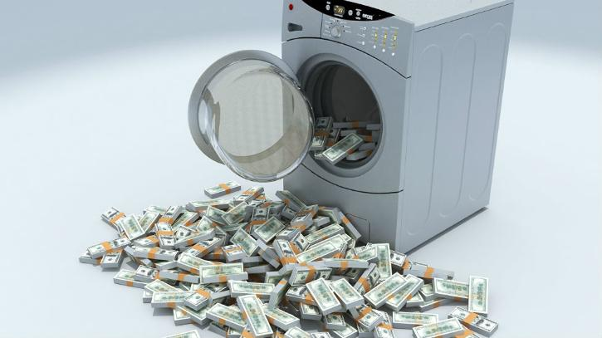

He was convicted of tax crimes.

THE TRUTH
During the Prohibition, US syndicates legalized their profits by combining their illicit gains with legit businesses.
They mixed their illicit earnings with the fair payments from these businesses.

Capone’s trial was a warning for them and they started paying their taxes to look legit !
Once they started paying their taxes, tax evasion laws became useless to combat them.

That’s when money laundering legislation developed.
However, it only became efficient when drug trafficking emerged ...... and with political corruption revealed in the Watergate Scandal.

Nixon, the Watergate and money laundering

In the 1970s, Republican president Nixon sent agents into the headquarters of the Democrats.
The agents burglared the headquarters to find information on them.
They were arrested by the police in the headquarters.

Forrest Gump scene
https://www.youtube.com/watch?v=na67qos-_h0

This operation was financed by dodgy money :

$1.7‐million in cash was raised (from Republican donors) just as a law requiring public reports of campaign contributions became effective.

Some of the money was “laundered” through a bank in Mexico.
About $700,000 of that money was deposited in banks.
$1m was placed in safes and safe deposit boxes.
$350,000 was placed in a White House safe belonging to Nixon’s chief aide.

Part of this money was in the possession one of Nixon’s agents when he was arrested.

After Nixon resigned in 1974, the phrase « money laundering » started to be used.
Anti-laundering legislation was reinforced. But was it enough ?

More recent money laundering scandals
The Panama Papers (2016) : revelations
214,000 offshore companies , thousands of prominent individuals
11.5 million leaked confidential documents
Panamanian law firm Mossack Fonseca assisted clients in setting up secretive offshore accounts to evade taxes and launder money.

HSBC Holdings : more than $881 million in money laundering services to various drug cartels (Mexico, Colombia)
HSBC paid a $1.9 billion fine in 2012

Wachovia Bank (2010)
2004 to 2007 : Mexican drug dealers criminals used the bank to transfer illegal profits (in US dollars as currency) across the Mexican border
The bank was unable to trace the source of these funds
13 billion dollars were transferred through Wachovia bank accounts to purchase airplanes for the use of drug trafficking in Mexico.
The bank paid the US government up to $110 million.
Hezbollah was using Wachovia accounts.

+ many others, including Danske Bank and Bernard Madoff’s “investment advisory services” (part D)

- Extent and dangers

According to the United Nations Office on Drugs and Crime,
global money-laundering transactions account for roughly $800 billion to $2 trillion annually
2% to 5% of global gross domestic product (GDP).

More details

Economic impact (indirect costs)

making home prices unaffordable
(ex : London property market speculation)

accelerating economic cycles (booms and busts)

volatility in international capital flows

more corruption and bad governance
(Greece’s 2004 Olympic games : Siemens corruption scandal)

untrustworthiness (lack of trust in banks, governments and institutions ; conspiracy theories)
(development of cryptocurrencies to by pass government control)

political instability

impact on emerging nations

poor regulatory system ; little official control

Sub saharan Africa « exports » illegal money : $1.3 trillion since 1980
= drain on domestic revenues , less local development , less investment , lower savings rate
= social gap, low infrascturture development, environmental degradation

Impact on the banking system
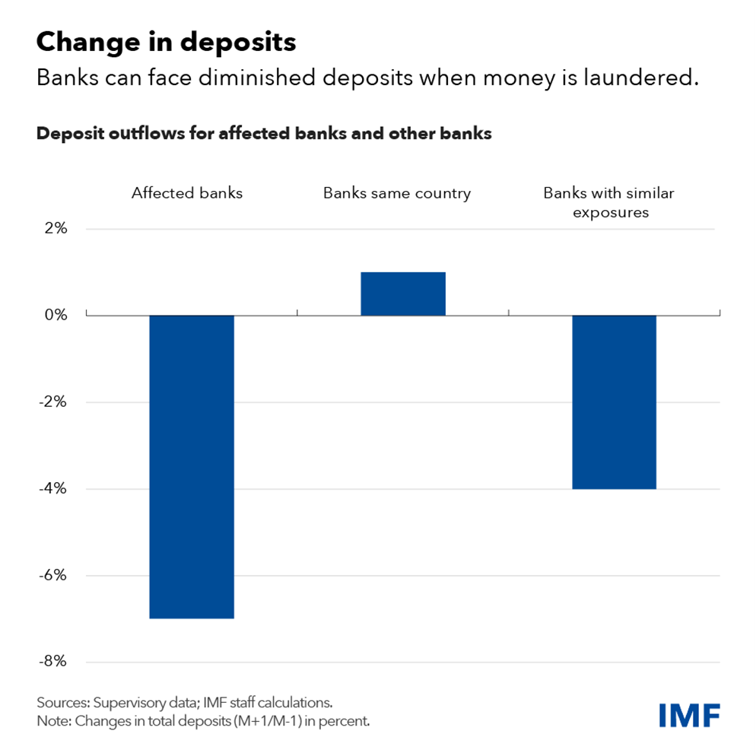
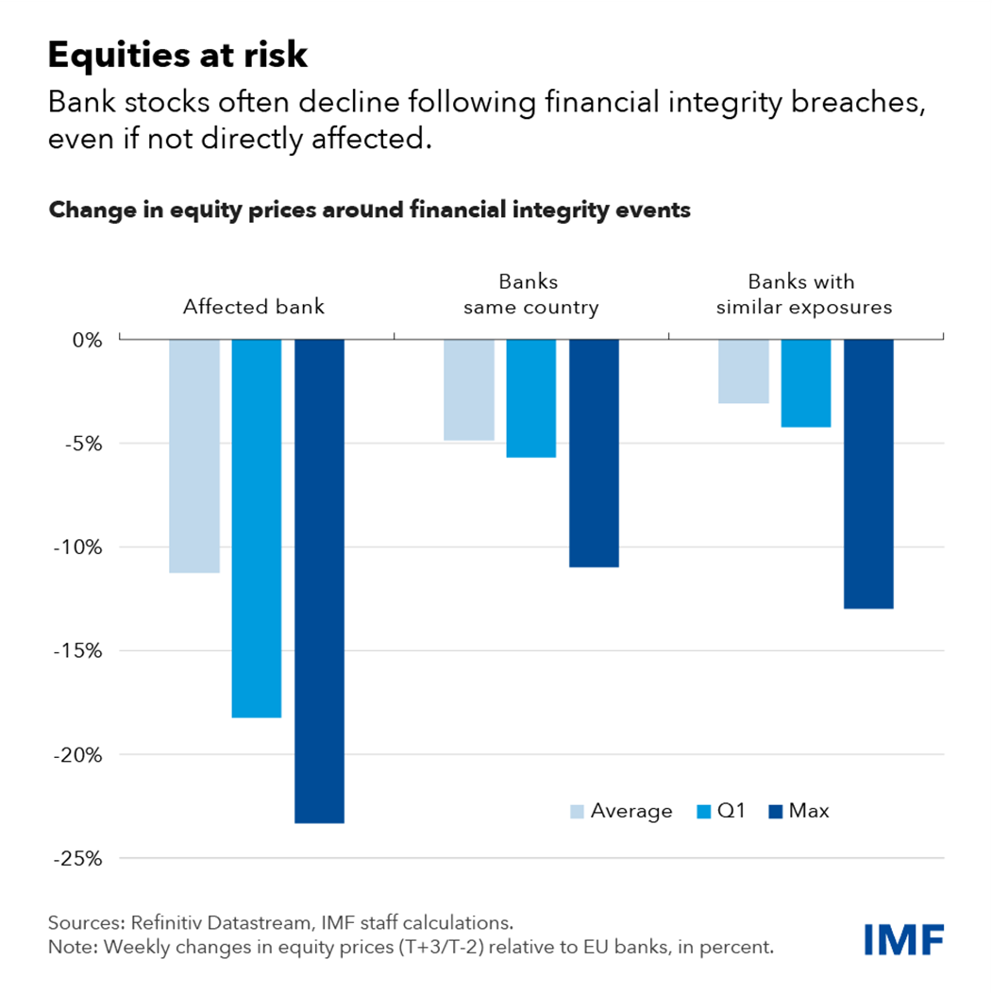

- How to control money laundering

Monitoring principles and goals
Regulation:
Determination of minimum legal standards for financial products.
Supervision:
To ensure that financial institutions operate safely and comply with specific anti-money laundering regulations.
Authorization:
To authorize financial institutions that fulfill the requirements.
Enforcement :
To identify, expose and prosecute non compliant firms
C1. Main AML agency : The Financial Action Task Force (FATF)
FATF is an intergovernmental organization
36 countries, strong powers worldwide.
goals :
to prevent money laundering and terrorist financing
to set global standards to ensure Anti-Money Laundering compliance. (a "policy-making body."
General Assembly (three times a year)
the member financial institutions of these organizations must comply with these existing regulations and new money laundering regulations.
FATF imposes sanctions on financial institutions that do not comply with regulations.

The FATF blacklist
countries that are deemed to have insufficient measures in place to combat money laundering and terrorist financing.
economic consequences :
restrictions in international financial transactions and investments.
non compliant nations : less attractivity for foreign investments international business
pressure to improve their AML and CTF regimes to be removed from the blacklist

C2. US AML legislation
…… money laundering was only banned in the USA in 1986!

1970 Bank Secrecy ACT :
aim : to help identify the source, volume, and movement of currency and other monetary instruments transported or transmitted into or out of the United States or deposited in financial institutions
Banks were henceforth required to …….
report cash transactions over $10,000
properly identify persons conducting transactions
maintain a paper trail by keeping appropriate records of financial transactions

Reinforced later by more acts (examples) :

goals :
1980s : to curb drug trafficking
1990s : to enhance financial surveillance
2000s : to cut off funding for terrorist organizations.

Money Laundering Control Act (1986)
money laundering is a federal crime
evading CTR filings is illegal
BSA violations can lead to prosecutions and lawsuits
bank procedures to ensure and monitor compliance with BSA requirements

USA PATRIOT Act (2001)
stricter customer identification procedures
financial institutions can’t do business with foreign shell banks
government-institution information sharing
voluntary information sharing among financial institutions
more civil and criminal penalties for money laundering
more powers for the Secretary of the Treasury to impose "special measures" in case of "primary money laundering concern"
banks must provide records access to the Treasury within 120 hours
federal banking agencies must consider a bank's AML record when reviewing bank mergers, acquisitions, and other transactions between financial institutions
financial institutions must have due diligence procedures
Due diligence :
Identifying and verifying the customer’s personally identifiable information
Identifying and verifying the identity of beneficial owners with a stake of 25% or more in a company opening an account
Understanding the nature and purpose and compiling risk profiles of customer relationships
Monitoring suspicious transactions and updating customer information

If there is suspicion of money laundering activities, a Suspicious Activity Reports (SARs) must be sent to public financial agencies.

Related US agencies
Financial Crimes Enforcement Network (FinCEN)
founded in 1990
bureau of the United States Department of the Treasury
aim :
to combat money laundering and terrorist financing
collecting, analyzing, and spreading relevant knowledge
legal bases : the Bank Secrecy Act (BSA).
requirement from financial institutions to report suspicious transactions and maintain proper records.
collaboration with many domestic and international partners to combat financial crimes.

Office of Foreign Assets Control (OFAC)
established in 1950.
an agency of the United States Department of the Treasury.
aim :
to impose sanctions on entities that pose a threat to U.S. national security.
to detect money laundering entities
to restrict illicit activity
to impose economic sanctions programs.

= enforcing compliance with US sanctions laws and regulations
= maintaining a list of specially designated people and banned individuals.

C3. UK AML regulation
The Financial Conduct Authority (FCA)

Harmonisation with US and EU legislation (10 January 2020)
Aim : to incorporate international AML standards
(FATF standards + EU’s 5th Money Laundering Directive.)

goals :
to protect consumers
to increase market integrity
to promote fair competition

regulation / supervision / authorisation powers

the FCA’s redflags since 2020

suspicious transactions......
...... between parties based in high-risk third countries
...... without electronic identification processes
...... not face to face (ex : through web mediators or shell companies)

the suspicious customer is ......
......the beneficiary of a life insurance policy
..... the customer is a third-country national looking for a deal
(ex : residence rights / citizenship in exchange for transfers of capital/investment in UK corporations)

The transaction is related to .....
...... raw materials (oil, arms, precious metals)
...... cultural items / scientific items of rare value
..... agricultural products (tobacco)
....... protected species (ivory)

Electronic wire transfers (e-money)

thresholds for customer due diligence (CDD) :
customer due diligence is not required if the transaction involves ........
a maximum £150 amount which can be stored electronically
a non-reloadable payment instrument
a maximum limit on monthly payment transactions of €150 (used in the UK only)
a purchase of goods or services

anonymous electronic money cannot be used to fund the payment instrument.

Due diligence is mandatory in all the other cases

Firms must monitor their beneficial owners
= a person who enjoys the benefits of ownership even though the title to some form of property is in another name (investopedia.com)
Example
Securities (bonds, shares) held by a broker/trader :
the true owner is the beneficial owner
the broker offically holds the ownership title
reason : safety / convenience

Firms must.....
... be aware of the ownership and control structure of their corporate clients
.... update their records on the beneficial ownership of corporate clients
.... record the difficulties encountered in identifying beneficial ownership
.... report discrepancies to Companies House
(information the firm holds on their clients /
information held by Companies House)

Companies House definition (www.gov.uk)

«Companies House is an executive agency, sponsored by the Department for Business and Trade.
What we do :
We incorporate and dissolve limited companies.
We register company information and make it available to the public.»

C4. Monitoring cryptos

Anti-Money Laundering and Cryptocurrency
cryptocurrency and blockchain analytics firm Chainalysis :

addresses connected to illicit activity :
2022 : nearly $39.6 billion worth of cryptocurrency
= up 141% from 2021.
2023 : dropped to $24.2 billion in 2023

about 0.78% of all illicit funds .....
……. has everything been detected?
Virtual coins provide anonymity (convenient way to store and move money)

Traditional AML frameworks are made for centralized financial institutions
= inadequate for the decentralized cryptocurrency ecosystem

Moves to regulating cryptos

Before 2020, in the U.S : cryptocurrency markets were unregulated
few regulations explicitly targeted it
………….. AML enforcement actions prosecuted under existing laws and statutes ! (Bank Secrecy Act, Foreign Corrupt Practices Act).
Ex : FTX scandal

Bitcoin can be made traceable.
regulators have made significant progress

Government agencies (IRS, FBI, etc.) can trace transactions to individuals.
a Bitcoin wallet address and its history can be analysed.

First change in 2020 : Anti-Money Laundering Act
Businesses that exchange or transmit virtual currencies are considered as regulated entities
they must register with FinCEN, adhere to AML and CFT laws, and report suspicious customer information to financial regulators.

Since 2022 : more IRS control on cryptocurrencies
a significant budget boost in 2022
87,000 agents for AML enforcement.
Crypto Exchanges must conduct detailed KYC (=”know your client”) checks
= personal and financial information on clients (including biometric data).
(2025 plan : obligation to disclose transaction data on IRS files)

Blockchain analysis : identification of suspicious cryptocurrency transactions.
= association of crypto wallets, exchanges, and transactions to designated terrorist organizations, sanctions lists, political groups, government actors, and organized crime.

Subpoenas allow the IRS to extract data from cryptocurrency exchanges and financial institutions to investigate tax evasion and money laundering.
Crypto Exchanges, under government pressure, collect and share customer data, linking crypto wallet addresses to personal identities.
= The blockchain enables IRS agents to view transaction records once the transaction ID has been obtained.

impact on the brand image of crypto exchanges :
Compliant exchanges offer more security by adhering to IRS reporting and KYC norms, ensuring asset protection.
a non-compliant exchange looks fraudulent and unreliable

More plans for the future (under negotiation worldwide)
financial platforms : obligation to report digital asset payments and transactions to national and transnational regulatory bodies, law enforcement agencies, and industry stakeholders.

an international AML system that would require collecting and sharing beneficiary information for cross-border cryptocurrency flows.

Efficiency ?
progress made on technical compliance (new laws)
effectiveness of these efforts ?
The overall efforts are still broadly insufficient.

under the radar
ex : the UK’s FCA regulations on e-money
What if a money launderer breaks up dirty money into £100 transactions ?

catching up with geeks and hackers
Web technology evolves quickly and tend to make money untraceable

Fiscal havens
The FATF’s « high-risk jurisdictions »
= « black list » of non compliant nations
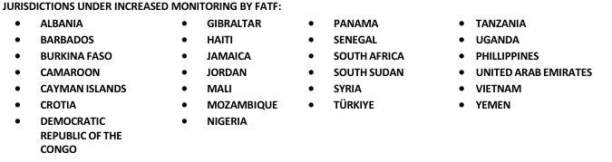

The law has no teeth
very little laundered ill-gotten proceeds are confiscated.
Some criminals escape detection for years before they are caught.

The impact of deregulation
Main objective : to reduce the scale and responsibilities of government
to boost business / to curb inflation
Ronald Reagan : “don’t count on the government to solve the problems…..
government IS the problem!”
US
aim : less government intervention on the financial market
lower taxes for corporations and wealthy people
a nationwide banking system (instead of statewide banking networks)
relaxation of the ceiling on interest rates to combat inflation
When regulations are lifted, investors are free to take on more risk.

UK
Margaret Thatcher : City deregulation (“Big Bang revolution”):
Cheaper transactions : abolishing minimum fixed commissions on trades
Fusion of distinct activities : stock-trading firms / advisory investors
Globalisation : allowing foreign firms to own UK brokers

problems in monitoring
Due to the spread of ultraliberalism in the 1980s, control agencies’ budgets have been slashed in the US and in Britain.
staff is insufficient.
control has been slow and limited.

Too much credit has been given to apparently trustworthy companies.
Monitoring agencies have been afraid to destroy public confidence in markets.
….. some monitoring agents might have been bribed.

- Examples

D1. the Danske Bank scandal

Summary of the case
Branches in Estonia generated approximately $236 billion. T
breakdown in communication between the management of Danske Bank‘s Copenhagen office and the Estonian branch.
thousands of suspicious customers who used the bank’s management flaws to conduct illegal transactions ($228 billion between 2007 and 2015).
Dodgy clients from Russia and other former Soviet states
Scheme : funds were moved through offshore companies and complex transactions.
= serious flaws in Danske Bank’s anti-money laundering controls
the bank failed to detect and prevent illegal activities in its branches.
In the aftermath of the scandal, the bank’s top executives, including its CEO, resigned, and the reputational damage inflicted on Danske Bank was significant.
The Danske Bank money laundering case has sparked a broader debate about the need for increased regulatory oversight and anti-money laundering measures throughout the global banking industry.

- money laundering at the Estonian branch
the acquisition of Sampo Bank
Extent of the scandal (figures, duration, geography)
From Kaliningrad to Estonia to “Londongrad”!
detection ; no action for years
media pressure : public confession / sanctions

- Why are Russian investors dodgy?
the end of the Soviet Empire (1991)
corruption culture (Soviet traditions)

- Why didn’t Danske Bank intervene?
(poor monitoring)
(fear for Danske Bank’s brand image)
(easy money)

D2. Bernard Madoff’s “ investment advisory services”

- Ponzi schemes (definition)
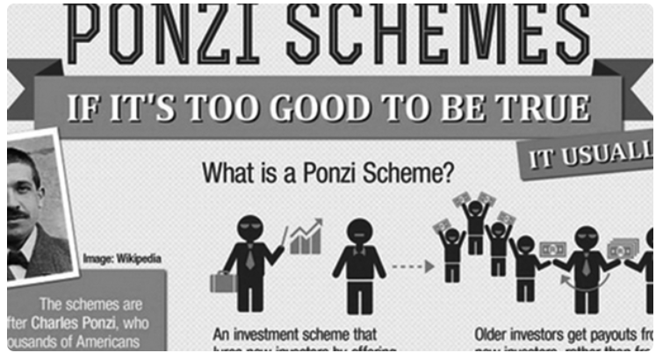
Charles Ponzi became famous in the 1930s for setting up a huge money scam.
He promised his investors ………………………………………….. , which is almost impossible.
However, because of Charles Ponzi, thousands of Americans ………………………
The principle of a Ponzi scheme can be defined as “……………………. “

This means that Ponzi’s investors didn’t really benefit from any investment made by Ponzi.
Instead, they were paid by ………………………

But a Ponzi scheme can’t last forever.
Once the pool of newer investors dries up, ………………………………..

In the 2000s, Bernard Madoff managed to break Ponzi’s record by a large margin.
Ponzi “only” defrauded US investors of $10m, which amounts to ………………….
However, Madoff managed to ………………………..

As a conclusion, if you are invited to invest in a scheme, you should be careful.
When an investment seems too good to be true, …………… and …………..

lost all their savings
a regular 50-percent return rate on their money within 90 days
the scheme collapses
about $114m in today’s money
robbing Peter to pay Paul
it’s probably a scam
embezzle $69 bn from 2000 to 2008
offers incredible returns (=dividends, profits)
don’t join the pool of investors
newer investors who join the scheme
you should warn the authorities


- Madoff’s fraudulent scheme evokes the double life of psychopaths

19th floor of the “Lipstick building
”legit investment and stock exchange business (or “front”)
stock exchange transactions
investment
CEO : Bernard Madoff, reputed to be a finance wizard
???? compliance officer : Madoff’s brother
???? no registration at the SEC (Security Exchanges Commission)

17th floor : Madoff’s hidden Ponzi scheme
(few people had access to it, knew about it or wanted to know about it)
no official registration
old computers and printers
no records of transactions / no regular information to clients
forged documents
false information on financial returns
(extravagant promises on interest rates, on a constant growth)
goal : finding as many clients as possible to “Rob Peter to pay Paul”
recruitment of clients : family, friends, colleagues, word of mouth
enormous success (mom and pop savings / drug barons / European aristocrats / US millionaires)
worth of Madoff’s Ponzi scheme in 2006 : $69bn

- why the scheme involved money laundering (an example)
bank accounts in the Cayman Islands (fiscal haven : no tax, little control, no traceability on the investors)
problems about Madoff’s legit business or “front” (1998 -2002)
they reveal how the scheme functioned

2000s : more competition / less productivity for Madoff (insolvency risk)
overstaffing : 35-50 traders // 150 employees
bad financial practices : regular presents to staff, friends and family
(ex : loans which were never paid back)

solution : $800m secretly transferred from the “17th floor” to the “19th floor”
money disguised as investments in US Treasury Bills (=short term bonds)
sent to the LSE to be laundered
reinvested into Madoff’s legit business

More details from the FBI archives (Madoff and money laundering)
BLMIS = Bernard L Madoff’s Security Services

2002-2008 : more than $250 million of BLMIS clients' funds were directed, through a series of wire transfers, to the operating accounts that funded the operations of these businesses.
MADOFF caused those investor funds to be sent from a BLMIS account in New York City to accounts held by BLMIS-affiliate MSIL in London, United Kingdom (the "MSIL Accounts").

He then further caused funds to be transferred from the MSIL Accounts to either the BLMIS Client Account or to another bank account in New York City, which was principally used to fund BLMIS's operations.
To conceal his scheme, MADOFF withheld information from regulators and repeatedly lied to the SEC in written submissions and in sworn testimony.

Why did MADOFF order these wire transfers ?
to give the appearance that he was conducting securities transactions in Europe on behalf of the investors (when, in fact, he was not).
to keep his legal operations running (“17th floor”) with legit cash, and avoid bankruptcy.
to purchase and maintain property and services for the personal use and benefit of MADOFF, his family members, and associates.

= Madoff gave millions to friends and colleagues, expecting them to return the money in times of financial problems ….. to keep BLMIS looking solvent

- how the scheme collapsed

d1. How Madoff’s scam should have ended

psychological “disassembling” ?
pressure from the press
pressure from experts
pressure from SEC investigators

main point : Madoff’s untrustworthiness
you can’t promise (and publish) 10%returns over more than 10 years!

murky investments
little information to clients
no traceability
no records
no official registration as an investment advisor

More details : FBI archives
(BLMIS : Bernard L Madoff Investment Security Services)
(SEC : Security Exchange Commission)

MADOFF caused fraudulent certified financial statements for BLMIS, including balance sheets, statements of income, statements of cash flows, and reports on internal control, to be created.
MADOFF caused such fraudulent financial statements to be sent to clients and prospective clients and to be filed with the SEC.
MADOFF knew that the certification attached to the BLMIS financial statements falsely averred that those statements had been prepared in accordance with Generally Accepted Auditing Standards and Generally Accepted Accounting Principles.

The idea that BMIS was untrustworthy was unthinkable !
(““what do you mean, you don’t trust Madoff?????”)
(“it’s from Madoff….. so it must be legit!”)
No going back …. reaction of denial
(..... “well, I invested all my family’s money into BLMIS…. so he MUST be legit!”)

Emergency steps
Madoff eventually yielded to pressure in the 2000s
personal visit to the SEC
he disclosed the names of his banking partners
this should have led to the collapse of his scheme……
…… but the SEC didn’t take any action !

d2. How the scheme actually collapsed
Madoff was undone by the 2008 mortgage crisis

fundamental needs of a Ponzi scheme :
actual financial returns to reassure current investors and keep them
availability of potential investors (“robbing Peter to pay Paul”)

mortgage crisis : collapse of financial returns
collapse in share value
panic selling of shares

mass withdrawal of funds from Madoff’s investors
no new investors
bankruptcy

Madoff confessed to his sons
they turned him over to the authorities
his company was liquidated (2008)
he was sentenced to 150 years in jail (2009)
he died in 2012

some of Madoff’s convictions :
fraud
money laundering
International Money Laundering to Promote Specified Unlawful Activity
International Money Laundering to Conceal and Disguise the Proceeds of Specified
Unlawful Activity

The victims
compensation plan :
Madoff’s successful investors were asked to refund those who had lost their money.
(= many lawsuits to oppose the plan)
this plan isn’t so absurd as it looks…..

Some of these investors were naive innocent people from various backgrounds
estimate : 37,000 people in 136 countries over four decades.

Celebrities :
film director Steven Spielberg
New York Mets owner Fred Wilpon
Nobel Peace Prize winner Elie Weisel

French investor and millionaire Rene-Thierry Magon de la Villehuchet
he invested all his clients’ money (including his friends’ and family’s) into Madoff’s scheme
total amount lost : over $1 billion (tens of millions of dollars of his own fortune)
he committed suicide in December 2008.

Other investors were fraudulent (=Madoff’s accomplices)
(=many prosecutions associated to Madoff’s)
Many of Madoff’s family and friends

more details on the compensation plan
MVF (Madoff Victims’ Fund)
over $4 billion has been made available to victims
….. money confiscated from Madoff’s pals (or accomplices) !
$2.2 billion
(forfeiture recovery from the estate of deceased Madoff investor, Jeffry Picower)
$1.7 billion
(forfeiture from JPMorgan Chase Bank)

more money from investor Carl Shapiro and his family
more from Madoff, his brother Peter B. Madoff, and their co-conspirators.

d3. Madoff and the SEC

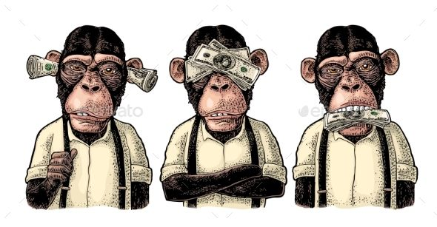
major monitoning failings : « see no evil, speak no evil »

Was the SEC .......
Dysfunctional ?
Careless ?
Inefficient ?
Incompetent ?
Corrupt ?

Four main laws that the SEC uses to regulate the financial sector
the Securities Act of 1933
= rules mandating public disclosure of information to investors in securities
Securities Exchange Act of 1934
= governs securities already issued (includes the laws barring insider trading)

Investment Advisers Act of 1940
Investment Company Act of 1940
= tools for prosecuting fraud and malfeasance from finance advisors
(mutual funds, hedge funds, investment managers.)
theoretically, Madoff should have been regulated under these two acts

Background : the SEC’s lack of response to white collar crime
Whistleblower action from finance lawyer Kathleen Furey
Furey joined the SEC in September of 2004
she was promoted three times over the next three years.
.............. 2008 : she was demoted

2007 : she work on a case that involved Value Line
= fraudulent mutual funds
They charged tens of millions of dollars in bogus commissions.

Investigation denied by Furey’s director
Furey appealed to his superiors
Cassandra warning : pursuing such cases “may save the agency from future embarrassment.”

Furey realised that the SEC systematically refused to take IM action
(=action against fraudulous investment advisers)

January 1, 2002 -- January 2009 : not a single case was examined under the Investment Advisors Act (IAA) or Investment Company Act (ICA).

End of 2008 : Madoff scandal
= very embarrassing to the SEC
Failure to investigate Madoff for years
..... despite Furey’s warnings
..... despite detailed tips from investigator Harry Markopolos for 8 years !

the SEC would have been able to uncover the fraud with just a short examination of Madoff’s investment company !

Start of 2009 : Congress asked the SEC questions
Congress controls the regulator’s budget.
SEC response : 9 investigations began (IAA or ICA cases).

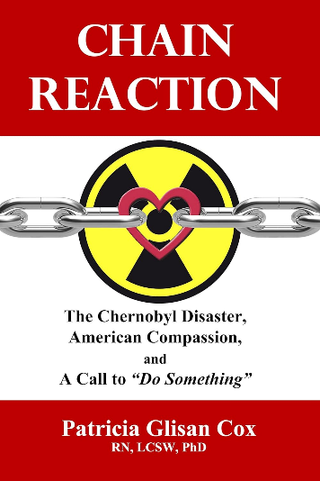
Another explanation :
Were the SEC afraid to inquire on Madoff ?

At Wall Street, everybody trusted Madoff
Many investors had pooled all their money at his investment firm
Some of them actually made a lot of money

What if Madoff were suspected of fraud ?
Markets rely on trustworthiness

Risk : setting up a « Chernobyl » chain reaction
Inquiry on Madoff
investors’ panic
Mass selling of shares
Loss in share value
Stock exchange crash

......... context : unstable situation around 2006-2008
Casino capitalism
Financial bubble
Vast expansion in share value ; vast profits
Toxic assets

More explanations :
Unqualified staff : the rat race
only « politically safe » people were promoted, not efficient staff
effects of 20 years of deregulation
few staff, reduced budgets
corruption : Madoff had friends in high places
what if SEC bosses had invested into Madoff’s company ?
what if they received gifts from him ?

d4. Conclusion on Madoff – how to avoid Ponzi Schemes

Beware of promises of unrealistic returns.
Any legitimate investment involves risk.
Red flags (clear warning signs) :
Guarantees of unrealistically high returns
delivering consistent 10 percent returns for decades
unrealistic and/or impossible – “Too good to be true”

Diversify – everything.
Don’t put all of your eggs in one basket (=Diversify)
your assets
your money managers
your accounts
your financial institutions

Diversification will limit your exposure to the financial problems of any one institution.
Two categories of victims in the Madoff case :
those who were financially stable after the scam
(they had invested only a percentage of their assets with Madoff, not their entire life savings).
those who relied on Madoff alone and lost everything

Don’t rely on word of mouth alone (=hearsay is unreliable)
Con artists are experts at building networks of trust
Madoff made investors think he had “inside” tracks on hot investments.
They invested because :
they trusted Madoff
friends and even family members, encouraged them to do so

Verify the investment details.
Ask detailed questions about the investments and those selling the investments
Demand clear and direct answers before you invest.
In the Madoff case, clients were told that the investment strategy was proprietary
These details (Madoff said) could not be disclosed.
In these cases, walk away.
Likewise if the investment is opaque or murky (for example if if you don’t understand it)

Check the auditor
A legitimate investment company managing multi-billion dollars of assets under management would use a reputable, nationally known auditing firm.
Auditors sign and certify financial statements of companies and investment funds.
They expose inaccuracies and they are accountable for them.
So ask your financial adviser to check the auditor of the fund you want to invest in.

Although Madoff case allegedly had over $50 billion in funds, the auditor was :
unknown
hard to-locate
only three purported employees responsible for reviewing such an extensive portfolio
….. but no investor raised an eyelid!

Background Check.
Securities regulators determine if the individuals and firms selling the investment are registered with your state/province.
Anyone selling a security must be registered.
For a very long time, Madoff refused to register.
If the promoter says he’s exempt, follow-up with your regulator to confirm the claim.
Check the promoter’s complaint history when you call.

Call your state/provincial securities regulator if you realise you are victim of a Ponzi scheme. Local securities regulators can investigate the matter.
Your call may help others from being victimized by the same scam.

Ad hoc websites report on financial fraud and help victims talk to each other.
They can also expose criminals and prevent them from defrauding other people.

