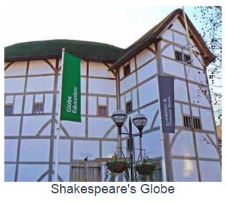
THE SHAKESPEARE GLOBE TRUST

WEBLINKS
http://www.swanlondon.co.uk/shakespeares-globe/
http://www.swanlondon.co.uk/the-globe-theatre/
http://www.shakespearesglobe.com/about-us
http://www.shakespearesglobe.com/education
http://www.pocketbritain.com/ShakespearesGlobe.html

BUILD A REPORT FROM THESE QUESTIONS

Why is William Shakespeare famous?
In which parts of the world is he very famous?
Where and when did he live?
What was Shakespeare’s Globe and why did it disappear?

What is the “New Globe”? Who built it, when and what for?
How much did it cost?
What is peculiar (=unusual) about it?
How can you get there?
Is it an expensive attraction?

What is a trust?
What kind of people does the Shakespeare Globe Trust attract every year?
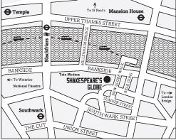
What about its turnover?
How many employees has it got?
In which activities is it involved?


