Université de Lorraine
DULASP Intermédiaire

M4 Préparation aux tests linguistiques en anglais

Examen Final
Semestre 2 2025

Duration: 2 heures

4 sections: Listening comprehension, Reading comprehension, Grammar, Writing

Name:

Date:

Section | Note
Listening

Reading

Grammar

Writing

Note Finale

You will write your answers on this booklet.

Please do not turn over the page until you are asked to do so.
Section 1: Listening Comprehension

PART 1 (Photographs)
You will hear 4 statements about each photograph. Circle the statement (A, B, C or D) that best describes the picture.

1. A B C D 2) A B C D
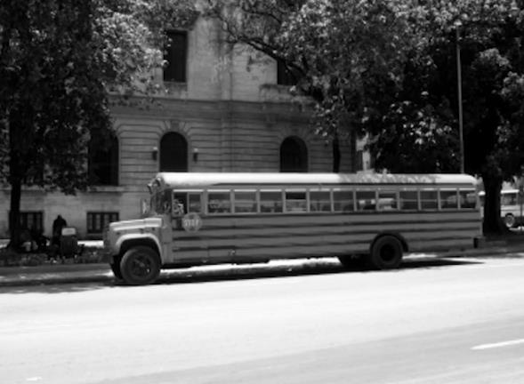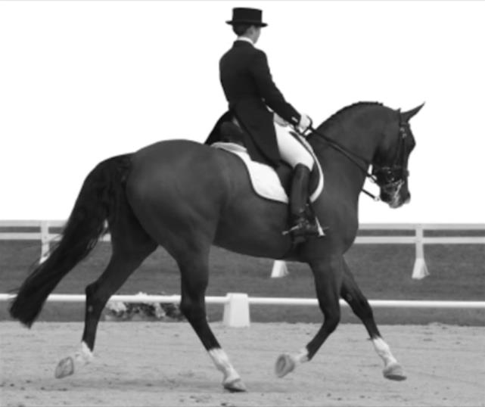

3) A B C D 4) A B C D
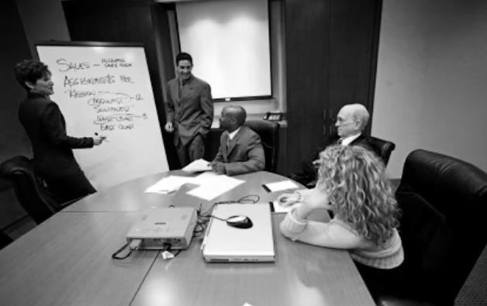

5) A B C D 6) A B C D
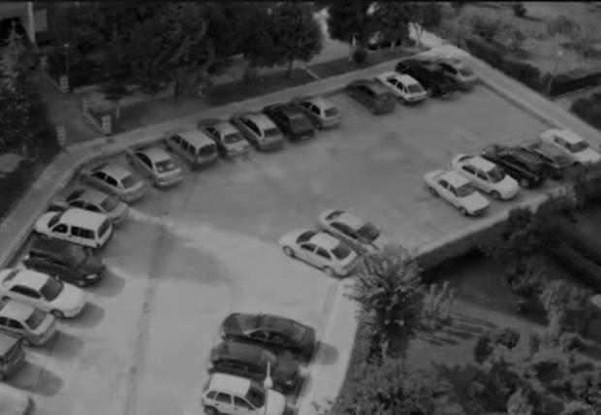

7) A B C D 8) A B C D
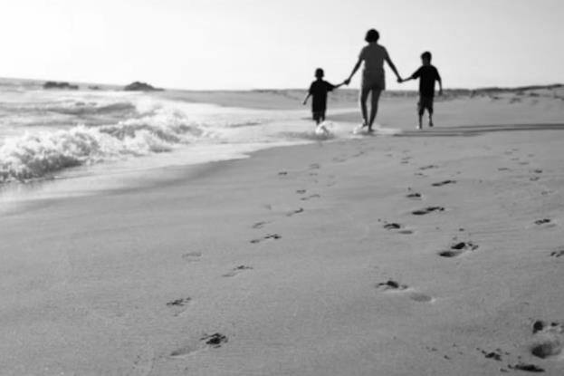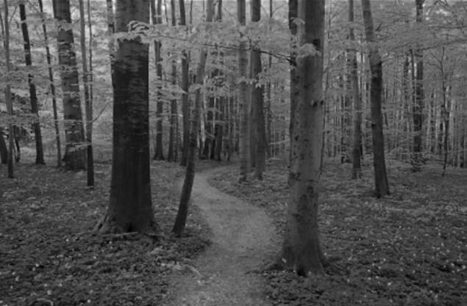

9) A B C D 10) A B C D
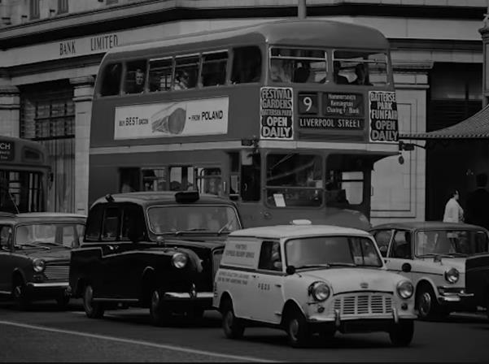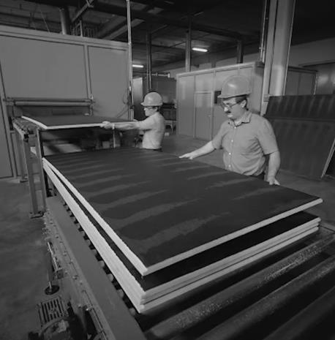

PART 2 (Question – Response)
You will hear a question and three possible answers. Circle the response (A, B or C) that best answers the question.

11) A B C
12) A B C
13) A B C
14) A B C
15) A B C
16) A B C
17) A B C
18) A B C
19) A B C
20) A B C
21) A B C
22) A B C
23) A B C
24) A B C
25) A B C
26) A B C
27) A B C
28) A B C
29) A B C
30) A B C
31) A B C
32) A B C
33) A B C
34) A B C
35) A B C
36) A B C
37) A B C
38) A B C
39) A B C
40) A B C

PART 3 (Conversations)
You will hear conversations between two people and you will see three questions to each conversation. Put an X in the box [X] next to the correct answer (A, B, C or D).

CONVERSATION 1 (41-43)
41) Where is Jason?
[ ] A. At the doctor’s office
[ ] B. In the office
[ ] C. At home resting in bed
[ ] D. On a business trip

42) How long has Jason been gone?
[ ] A. Two weeks
[ ] B. All year
[ ] C. All month
[ ] D. All week

43) Which of the following is Jason not doing to recover?
[ ] A. Eating chicken noodle soup
[ ] B. Resting
[ ] C. Gargling with salt water
[ ] D. Taking antibiotics

CONVERSATION 2 (44-46)
44) What does the woman want to do?
[ ] A. Get a new job working in real estate
[ ] B. Buy a house
[ ] C. Become a real estate expert
[ ] D. Buy some art

45) When will she make her decision?
[ ] A. In a couple of months
[ ] B. After the real estate bubble
[ ] C. When her husband tells her what do to
[ ] D. When the risk is greater

46) What are experts saying now?
[ ] A. It is a great time to buy a house
[ ] B. Real estate is a good investment
[ ] C. House prices will increase
[ ] D. It’s a bad time to buy a house

CONVERSATION 3 (47-49)
47) Why does the man buy cakes at the bakery?
[ ] A. Because they’re inexpensive
[ ] B. Because they’re higher quality
[ ] C. Because they don’t taste good
[ ] D. Because they are cheap

48) When does the man go to the bakery?
[ ] A. After work on Friday
[ ] B. Saturday mornings
[ ] C. Anytime he needs cookies
[ ] D. Friday mornings

49) What did the man bring to the picnic?
[ ] A. Sushi
[ ] B. Cakes and cookies
[ ] C. Doughnuts
[ ] D. Fresh fruit

CONVERSATION 4 (50-52)
50) What are they discussing?
[ ] A. A book
[ ] B. A movie
[ ] C. A play
[ ] D. A job

51) What is the woman’s opinion of Joseph Belleto? (the audio says ‘Mark Westbrook’ - this is a mistake)
[ ] A. She doesn’t like his work.
[ ] B. She thinks he is fantastic.
[ ] C. She thinks he is overrated.
[ ] D. She hasn’t made up her mind yet.

52) When will the man watch the movie?
[ ] A. Next week
[ ] B. This weekend
[ ] C. On a weekend
[ ] D. Today
CONVERSATION 5 (53-55)
53) What are the man and woman discussing?
[ ] A. Why his car needs to be serviced
[ ] B. What the software is for
[ ] C. Where the service shop is
[ ] D. An upcoming business trip

54) What problem does the man have?
[ ] A. The woman will not give him a ride from the shop.
[ ] B. The software is difficult to learn.
[ ] C. He doesn’t know how to implement the software.
[ ] D. He needs to have someone pick him up at the shop.

55) How long will the man be away?
[ ] A. Two days
[ ] B. Three days
[ ] C. Four days
[ ] D. Five days

CONVERSATION 6 (56-58)
56) When does the conversation take place?
[ ] A. At night
[ ] B. In the morning
[ ] C. In the late afternoon
[ ] D. Around midday

57) What are the speakers waiting for?
[ ] A. A call from New York
[ ] B. A new worker
[ ] C. The New York manager
[ ] D. A report

58) What does the woman suggest?
[ ] A. Hiring a new manager
[ ] B. Flying to New York
[ ] C. Making a phone call
[ ] D. Sending an email

CONVERSATION 7 (59-61)
59) What are the man and woman discussing?
[ ] A. Their supervisor and what he wants them to do
[ ] B. How to use the new email system
[ ] C. A meeting to introduce the company’s new products
[ ] D. What the new customers are like

60) What problem does the man have?
[ ] A. He doesn’t want to go to the meeting with the new customer
[ ] B. He has a conflict between two meetings
[ ] C. He feels his supervisor is treating him unfairly
[ ] D. He doesn’t like his supervisor

61) What is the man going to do to resolve the problem?
[ ] A. Ask his supervisor what to do
[ ] B. Ask the woman to talk to his supervisor
[ ] C. Talk to the new customer
[ ] D. Attend the mandatory meeting in the afternoon

CONVERSATION 8 (62-64)
62) What are the man and the woman trying to figure out?
[ ] A. When they can each get a haircut
[ ] B. Who will pick up the kids from school
[ ] C. Who is going to cook dinner
[ ] D. Who the woman will hire as a new assistant

63) Why can’t the woman pick up the kids from school?
[ ] A. She has to meet with her boss
[ ] B. She has to get her hair cut
[ ] C. She has to talk with her assistant
[ ] D. She has a dinner date

64) What was the man planning to do at 5 o’clock?
[ ] A. Go to a basketball game
[ ] B. Attend a meeting
[ ] C. Cook dinner
[ ] D. Get his hair cut
CONVERSATION 9 (65-67)

65) How many notebooks is the man ordering? (the audio says ‘pens’ – this is a mistake)
[ ] A. Ten
[ ] B. Twelve
[ ] C. Five
[ ] D. Seventeen

66) What colours does he want?
[ ] A. Black and grey
[ ] B. Brown and purple
[ ] C. Black, grey and brown
[ ] D. Red, black and blue

67) How will he pay for the notebook?
[ ] A. A woman will send him a bill
[ ] B. The woman will charge it to his account
[ ] C. He will pay by credit card
[ ] D. He will pay by check

CONVERSATION 10 (68 – 70)

68) What is the relationship between these two people?
[ ] A. They are a customer and a clerk in a store
[ ] B. They are two people who work together in a store
[ ] C. They are a boss and his employee
[ ] D. They are mother and son

69) What does the woman want?
[ ] A. She is going to purchase a gift for her mother
[ ] B. She wants to get money back for a purchase she made
[ ] C. She wants to find a DVD player for her TV
[ ] D. She wants to complain about a bad product she bought

70. What does the woman decide she is going to do?
[ ] A. She is going to purchase a gift for her mother
[ ] B. She is going to get a refund for a TV she doesn’t need
[ ] C. She is going to exchange the TV for another item
[ ] D. She is going to buy a new TV

Section 2: Reading Comprehension

Question 1: Read the following passage and answer the questions below. Put an X in the box [ X ] next to the correct answer.

Notice Board Space Available to Community Groups

Mooringtown Library is pleased to invite local community groups to use the free advertising space on its new notice board, located outside the front entrance of the library. Space on the board is available for up to four weeks at a time.

Notices must be approved in advance at the library’s front desk and must meet the following requirements. All content must be suitable for public display. The notice must be written or printed on standard-quality paper with dimensions of either 8.5 in x 11 in or 5.5 in x 8.5 in. The desired start and end date for display should be written in the front bottom right corner. — [1] —. Any notices that do not meet these requirements will not be considered and will be discarded. — [2] —.

— [3] —. Submissions are now being accepted at the Mooringtown Library front desk. Please have the actual notice, in the format in which you would like it to appear, with you when you arrive. Within one business day, you will receive a call confirming that your notice has been added to the board. — [4] —.

Mooringtown Library

1. What is indicated about advertising space on the Mooringtown Library noticeboard?
[ ] A) It is available at no charge
[ ] B) It can be used for any length of time
[ ] C) It is open to all area businesses
[ ] D) It is mainly intended for sporting events

3. What is NOT a stated requirement for a notice to be placed on the board?
[ ] A) It must meet certain size requirements
[ ] B) It must be marked with posting dates
[ ] C) It must be reviewed beforehand
[ ] D) It must be signed by a librarian

2. What should an advertiser bring to the library when making a submission?
[ ] A) An outline of the proposed content
[ ] B) A final version of the notice
[ ] C) A completed submission form
[ ] D) A letter from an organization

4. In which of the positions marked [1], [2], [3], and [4] does the following sentence best fit?
“The name and telephone number of the person posting the notice must be clearly marked on the back.”
[ ] A) [1]
[ ] B) [2]
[ ] C) [3]
[ ] D) [4]

Question 2: Read the following email and letter exchange and then answer the questions that follow. Put an X in the box [ X ] next to the correct answer.

To: The Shoe People <inquiries@shoepeople.com>
From: John Trimbald <jtconstruction@img.com>
Subject: Customer Complaint

To whom it may concern,

I have trusted The Shoe People to protect the feet of my employees for over ten years now. I recently purchased a few pairs of boots from your company for my crew. Though my men were initially satisfied with the boots, the soles began to fall apart on them after just twelve weeks. This was extremely surprisingly considering they came with a six-year warranty. The boots are unsafe to wear because my men are pouring hot concrete. Please respond as soon as possible with instructions on how I can return the boots and receive a refund.

Thank you,
John Trimbald

The Shoe People
22 Circular Road
Castlerock
Northern Ireland
BT51 6TP
John Trimbald
JT Construction
22 Mark Lane Road
London
England
EC38 4BT
January 3rd, 2019
Dear Mr Trimbald,

Thank you for your email concerning the poor quality of our rubber soled black work boots. A representative will be by your office next week to pick up the damaged boots. We apologize for any inconvenience this has caused you and you crew. Along with five new pairs of work boots for your crew (we included one extra pair), we have enclosed a free year’s supply of sole protector spray. In our retail stores, this spray is always recommended to buyers who work on heated floors. This should have been brought to your attention at the time of your initial order (received by telephone on October 12th, 2018). Please excuse our oversight. To date we have had no complaints about these work boots from customers who have used the protector spray. However, should you use the spray and find that you are still unsatisfied with the boots, please return the boots and the spray for a full refund. Thank you for supporting The Shoe People and have a Hapy New Year.

Sincerely,
Stan Mason, President

5. Which company was unsatisfied?
[ ] A) Stan Mason's company
[ ] B) The Shoe People
[ ] C) JT Construction
[ ] D) The sole company
6. How many people are on John Trimbald's crew?
[ ] A) Four
[ ] B) Five
[ ] C) Six
[ ] D) Twelve

7. What is the spray used for?
[ ] A) To protect the boots from water
[ ] B) To protect the soles from heat
[ ] C) To protect the floors from soles
[ ] D) To protect the boots from rubber
8. What should John Trimbald do if he remains unsatisfied?
[ ] A) Return just the spray
[ ] B) Call the President
[ ] C) Mail another letter
[ ] D) Request a refund

Question 3: Read the following passage about Madagascar and decide whether the following statements are TRUE or FALSE. Put an X in the box [X] next to the correct answer.

Madagascar – When to go

Madagascar has two seasons, a warm, wet season from November to April, and a cooler dry season between May and October. However, different parts of the country have very different weather.
The east coast is hotter and wetter, with up to 4000mm of rainfall per year. In the rainy season, there are strong winds, and these can cause a lot of damage. Avoid visiting eastern Madagascar between January and March because the weather can make road travel very difficult. The dry season is cooler and more pleasant.
The high, central part of the country is much drier and cooler. About 1,400 mm of rain falls in the rainy season, with some thunderstorms, but the summer is usually sunny and dry, but it can be cold, especially in the mornings, with freezing showers, and it may snow in mountain areas above 2,400m, and even stay there for several days.
The west coast is the driest part of the island. Here, the winter months are pleasant with little rain, cooler temperatures and blue skies. The summers can be extremely hot, especially in the southwest. This part of the country is semi-desert, and only gets around 300mm of rain per year.

9. Madagascar has four seasons: spring, summer, autumn, winter. …………..TRUE [ ] / FALSE [ ]
10. There is more rain in January than June. ……………………………….…………….TRUE [ ] / FALSE [ ]
11. The wet season is colder than the dry season. …………………………….…….. TRUE [ ] / FALSE [ ]
12. It hardly ever rains in central Madagascar. ………………………………….……… TRUE [ ] / FALSE [ ]
13. The wettest part of the island is the east. ………………………………….………..TRUE [ ] / FALSE [ ]
14. January-March is a good time to visit eastern Madagascar. …………….…..TRUE [ ] / FALSE [ ]
15. The centre of Madagascar is the coldest part. ………………………….………… TRUE [ ] / FALSE [ ]
16. Snow sometimes falls in Madagascar. …………………………………………….……TRUE [ ] / FALSE [ ]
17. The west coast has the best weather in December. ……………………….…….TRUE [ ] / FALSE [ ]
18. The north-east is hotter than the south-east. ………………………………………TRUE [ ] / FALSE [ ]

Section 3: Grammar

Part 1 – Choose the correct answer (A, B, C or D) to fill the gaps in these sentences. Put an X in the box [X] next to the correct answer.

- Sales will not increase _______________ we launch a more competitive product.
[ ] A) Unless
[ ] B) However
[ ] C) Although
[ ] D) Since

- The flight was cancelled _________ the snow.
[ ] A) Despite
[ ] B) Because of
[ ] C) Instead of
[ ] D) Whereas

- I have just received an ____________ from one of our suppliers.
[ ] A) Advice
[ ] B) Information
[ ] C) Form
[ ] D) Invoice

- If you ________ your passport, you must report it to the police.
[ ] A) Lose
[ ] B) Loose
[ ] C) Loses
[ ] D) Loss

- It would be _________ if you took the plane.
[ ] A) Quicker
[ ] B) The quickest
[ ] C) The quicker
[ ] D) More quickly

- Many people are not very __________ in politics.
[ ] A) Bored
[ ] B) Boring
[ ] C) Interested
[ ] D) Interesting

- When _________ work?
[ ] A) Does Luke usually start
[ ] B) Luke usually starts
[ ] C) Luke usually does
[ ] D) Luke usually

- Do you agree ____________ me at all?
[ ] A) With
[ ] B) At
[ ] C) To
[ ] D) For

- Sam was driving back home when his car ___________.
[ ] A) Has broken
[ ] B) Broke down
[ ] C) Breaked down
[ ] D) Broken

- It’s ______________ journey.
[ ] A) Seven hours
[ ] B) The seven hours
[ ] C) Seven o’clock
[ ] D) A seven-hour

- William and Maya phone __________ every evening.
[ ] A) Himself
[ ] B) Themselves
[ ] C) Each other
[ ] D) They

- ______________ they decided not to move to the USA.
[ ] A) Despite
[ ] B) In the end
[ ] C) In addition to
[ ] D) In order to

- Would you mind _________ my questions?
[ ] A) Answered
[ ] B) To answer
[ ] C) Answer
[ ] D Answering

Part 2 – Four words or phrases in the following sentences are underlined. Put an X in the box [X] of the option (A, B, C or D) that is incorrect.

- We read it your proposal with a great deal of interest.
[ ] A) Read it
[ ] B) With
[ ] C) A great deal
[ ] D) Interest

- Everyone who witnessed the accident were asked to give a statement to the police.
[ ] A) Everyone
[ ] B) Were asked
[ ] C) To give
[ ] D) The police

- Expect heavy traffic on all main roads leading out of the city because the holiday weekend.
[ ] A) Heavy
[ ] B) Leading
[ ] C) Out of
[ ] D) Because

- Increases in the prices of basic goods were announcing this morning by the President.
[ ] A) The prices
[ ] B) Goods
[ ] C) Announcing
[ ] D) By

- The coal is the world’s most abundant fossil fuel.
[ ] A) The coal
[ ] B) The world’s
[ ] C) Fossil
[ ] D) Fuel

- All of the students are looking forward spending their free time relaxing this summer.
[ ] A) Students
[ ] B) Are
[ ] C) Forward spending
[ ] D) Their

- The equipment in the office was badly in need of to be repaired.
[ ] A) Equipment
[ ] B) In the office
[ ] C) Was badly
[ ] D) To be repaired

- The manager has not decided how to deal with the new problems already.
[ ] A) The
[ ] B) Has
[ ] C) How to deal
[ ] D) Already

- I’m not agree with the suggestion you made over the weekend.
[ ] A) I’m not
[ ] B) With
[ ] C) Made
[ ] D) Over

- I tried to telephone to Anna this morning, but the line was always engaged.
[ ] A) To
[ ] B) This
[ ] C) The line
[ ] D) Engaged

- All employee are required to wear their identification badge while at work.
[ ] A) Employee
[ ] B) To wear
[ ] C) Identification
[ ] D) While

- The taxi driver told the man to don’t allow his son to shout.
[ ] A) Taxi driver
[ ] B) Told
[ ] C) Don’t allow
[ ] D) To shout

Section 4: Writing

Some people choose to work at one job for a long time. Others prefer to change jobs often.

Which way do you think is better? Use specific reasons and examples to explain your choice.

Write your response on the lines below:

_________________________________________________________________________________________________________________________________________________________________________________________________________________________________________________________________________________________________________________________________________________________________________________________________________________________________________________________________________________________________________________________________________________________________________________________________________________________________________________________________________________________________________________________________________________________________________________________________________________________________________________________________________________________________________________________________________________________________________________________________________________________________________________________________________________________________________________________________________________________________________________________________________________________________________________________________________________________________________________________________________________________________________________________________________________________________________________________________________________________________________________________________________________________________________________________________________________________________________________________________________________________________________________________________________________________________________________________________________________________________________________________________________________________________________________________________________________________________________________________________________________________________________________________________________________________________________
______________________________________________________________________________________________________________________________________________________
_________________________________________________________________________________________________________________________________________________________________________________________________________________________________________________________________________________________________________________________________________________________________________________________________________________________________________________________________________________________________________________________________________________________________________________________________________________________________________________________________________________________________________________________________________________________________________________________________________________________________________________________________________________________________________________________________________________________________________________________________________________________________________________________________________________________________________________________________________________________________________________________________________________________________________________________________________________________________________________________________________________________________________________________________________________________________________________________________________________________________________________________________________________________________________________________________________________________________________________________________________________________________________________________________________________________________________________________________________________________________________________________________________________________________________________________________________________________________________________________________________________________________________________________________________________________________________

