Section 1: Listening Comprehension
Part 1 (Photographs)
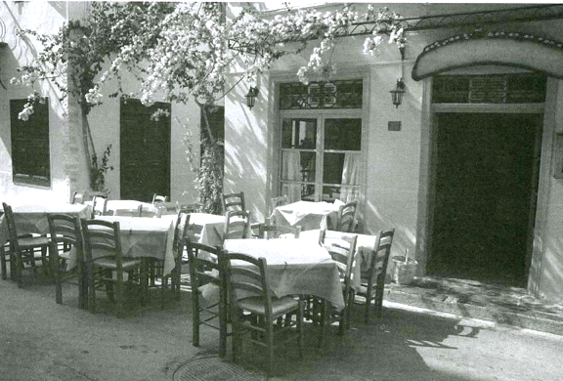
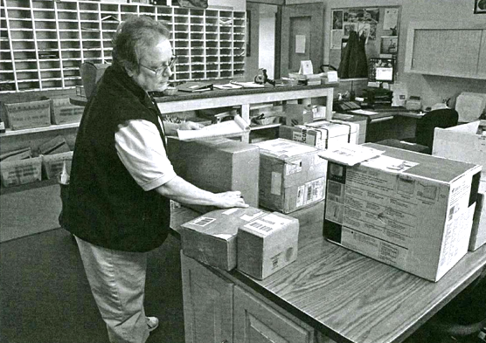
6) A B C D 7) A B C D

8) A B C D 9) A B C D
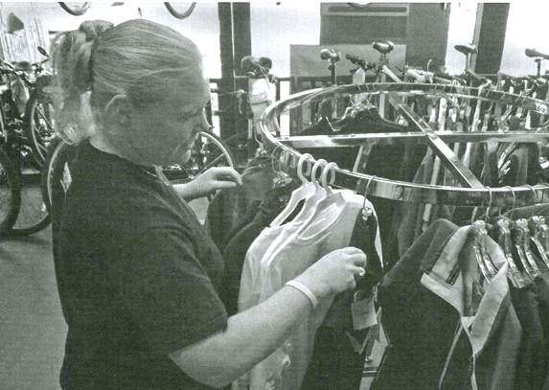
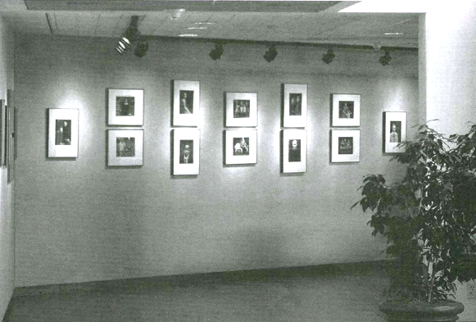
10) A B C D
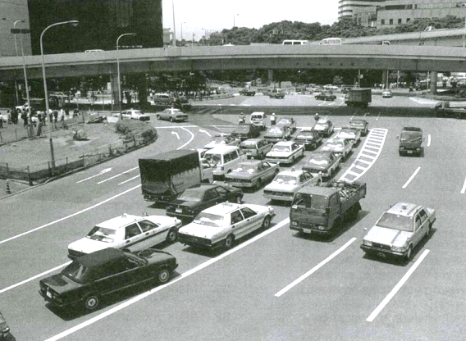

Part 2 (Question – Response)
26) A B C 27) A B C 28) A B C
29) A B C 30) A B C 31) A B C
32) A B C 33) A B C 34) A B C
35) A B C 36) A B C 37) A B C
38) A B C 39) A B C 40) A B C

Part 3 (Conversations)
Conversation 1:
32. Where are the speakers?
(A) In an office
(B) At a restaurant
(C) At the airport
(D) In the parade

33. Why is the traffic jam expected?
(A) Many people are going on a picnic.
(B) Construction is ongoing.
(C) There will be a street parade.
(D) There was an accident on the street.

34. What time will the speakers leave?
(A) At 5 p.m.
(B) At 6 p.m.
(C) At 7 p.m.
(D) At 9 p.m.

Conversation 2:
35. What is the purpose of the call?
(A) To promote a new service
(B) To make a complaint
(C) To inform a customer of unpaid bills
(D) To confirm a schedule

36. According to the woman, what was the problem?
(A) She was not aware of the new services.
(B) She could not meet the deadline.
(C) She was unfairly treated by a staff member.
(D) She may have forgotten to notify some change.

37. What will the man probably do next?
(A) Call a colleague
(B) Provide her with a discount
(C) Explain the procedure
(D) Update some information

Conversation 3:

38. Where do the speakers most likely work?
(A) At a bank
(B) At a supermarket
(C) At an employment firm
(D) At a business school

39. What does the man say he wants to do?
(A) Register for a management class
(B) Work as a cashier
(C) Hire a new loan officer
(D) Open a new account

40. What do the women say they will send the man tomorrow?
(A) Handouts from a presentation
(B) Brochures for financial services
(C) An application for the new position
(D) A list of some names

Conversation 4:
41. Where is the conversation probably taking place?
(A) In a restaurant
(B) In the office
(C) On the street
(D) At the park

42. What does the man say about the restaurant?
(A) It was too expensive.
(B) It was as good as its reputation.
(C) It was below his expectations.
(D) It was far away from the office.

43. What will the speakers probably do?
(A) Go out to eat
(B) Leave for the day
(C) Take a walk
(D) Order some food

Conversation 5:
44. Where does the woman work?
(A) At a theater
(B) At a dental clinic
(C) At a travel agency
(D) At a restaurant

45. How long did it take for the man to make a reservation?
(A) Three hours
(B) One week
(C) Two weeks
(D) Three weeks

46. What does the man say he will do?
(A) Cancel his appointment with his client
(B) Look for some reviews
(C) Book another time
(D) Finish the work early

Conversation 6:
47. What is the conversation mainly about? (A) A vacation trip
(B) Office supply purchase
(C) Changes in personnel
(D) Software installation

48. What does the woman mean when she says, “I knew that he would be promoted soon.”?
(A) She was notified about the news before.
(B) She is very close to Mr. Russell.
(C) She wants to get promoted, too.
(D) She thinks Mr. Russell has worked hard.

49. What will the woman do next?
(A) Call Mr. Russell
(B) Talk to a former colleague
(C) Interview an applicant
(D) Make a reservation

Section 2: Reading Comprehension
Question 1: Read this article.

On Monday, Salinas Products, a large food distributor based in Mexico City, announced its plans to acquire the Pablo’s restaurant chain. Pablo Benavidez, the chain’s owner, had been considering holding an auction for ownership of the chain. He ultimately made the decision to sell to Salinas without seeking other offers. According to inside sources, Salinas has agreed to keep the restaurant’s name as part of the deal. Mr. Benavidez started the business 40 years ago right after finishing school. He opened a small food stand in his hometown of Cancún. Following that, he opened restaurants in Puerto Vallarta and Veracruz, and there are now over 50 Pablo’s restaurants nationwide.

- What is suggested about Mr. Benavidez?
A) He has hired Salinas Products to distribute his products.
B) He has agreed to sell his business to Salinas Products.
C) He has recently been hired as an employee of a school.
D) He has been chosen to be the new president of Salinas Products.

- According to the article, where is Mr. Benavidez from?
A) Cancún
B) Veracruz
C) Mexico City
D) Puerto Vallarta

- What is indicated about the Pablo’s restaurant chain?
A) It was recently sold in an auction.
B) It will soon change its name.
C) It was founded 40 years ago.
D) It operates in several countries.

Question 2: Read these 2 emails between coworkers.

Hi,

Sorry for sending this to all the staff in the company, but my list of people who are going to the Signmakers’ Conference in Dartmouth is not up-to-date, so I thought I’d mail it to everyone just to be on the safe side.

The company has agreed to pay for transport by rail which means you won’t have to drive there yourselves. We’ve booked seats on the 0630 from Stanton Heath which goes direct to Dartmouth. We should arrive there by 0845, and we can then share taxis to get to the venue, which I understand is just a 15-minute drive, so we should easily make the 0930 start.

Hotel accommodation has been booked at the Premium Inn, Dartmouth. The management have agreed that all delegates should have their own rooms. It’s likely that some of you will have singles, while others will have doubles and twins. I can’t take request for double rooms, I’m, afraid. It will be the luck of the draw. All rooms will have ensuites, and should be very comfortable.

We’re planning return transport on the 2010 from Dartmouth which will get us back to Stanton Heath at 2200.

I’ll be booking transport on Friday morning (14th March), so if you have any queries or problems, make sure you contact me before then.
James Roxford

Dear James

Sorry, I didn’t get back to you in time. I was off sick last week and didn’t get your message until this morning. I hope you haven’t booked the train tickets yet. I’m planning to go to the conference by car, as I’m not returning to Stanton Heath after the conference. I’m going on to visit my family.
Is there any chance you can reserve a double room for me at the Premium Inn? I find it hard to sleep in single beds.

Thanks
Mindy Jacques

- James’s email was sent to:
- Mindy Jacques
- Staff who are attending a conference
- Visitors to James’s company
- Everyone in the company

- Which of the following is true about the journey James has planned?
- Delegates will take a different route on the return journey
- The delegates will arrive just after the conference starts.
- The return journey is faster than the outbound journey.
- The delegates will need to change trains on the outbound journey.

- When did Mindy send her email?
- Monday (17th March)
- Thursday (13th March)
- Friday morning (14th March)
- Friday afternoon (14th March)

- What is James likely to do after receiving Mindy’s message?
- Reserve a double room.
- Buy another conference ticket.
- Phone a taxi company.
- Cancel a train ticket.

Question 3: Read these 4 reviews for a hotel.
The Coach Hotel
Rating: ★★★☆☆ 164 reviews
Patsy190 writes:
6 of us stayed here for the weekend. The first thing we noticed on entering our room was how small it was. Our rooms were clean, but the bed cover was stained. The furniture was really outdated, especially the bathroom, which had an old pink suite and linoleum on the floor. The ‘shower’ was a hose that you fit onto the taps. The sink was in the bedroom, right next to the television sockets which seems pretty unsafe to me. We had dinner there, and it was well-cooked, but we were still hungry afterwards because the servings were so tiny. The drinks prices were extortionate - £5 for a small glass of wine. My friend ordered a brandy and coke, but the waitress brought him whisky and coke. When we complained, she just walked off! Not impressed. I would like to say it was cheap and cheerful but at £120 a night, it was neither - overpriced and depressing more like.
MellowBunny writes:
Just returned from a 3-day break here, and thought that the Coach Hotel was very good value for money. I had requested a quiet room and this was noted at reception. I got a great room - large, comfortable and clean, with a seating area overlooking the racecourse. The only disappointing thing was that there were no tea/coffee facilities in the room - not even a kettle. The furniture and decor were not particularly up-to-date, but that’s what you would expect from an old hotel. There was a wide selection of well-cooked food on offer. At breakfast I had poached eggs, and they were done to perfection. In the evening, I had a delicious three-course meal, and I wasn’t kept waiting for ages between courses, which is definitely a plus when you’re dining alone. I found the staff friendly and always willing to help.
TomWheeler writes:
The hotel’s is just 200 metres walk away from the racecourse, so it’s really convenient. There’s plenty of space to park. The bed was comfortable with clean cotton sheets. Good power shower. I would agree with some of the less favourable reviews on the site too, though. The room definitely needed some attention – it smelt musty and the furniture was old, cheap and battered. The bin hadn't been emptied from previous guests, and there was other rubbish on the floor. The fan in the bathroom was very loud, and the plumbing made strange noises in the night. The walls were thin too. Breakfast was okay, but there wasn’t much of it.
JadeUnicorn writes:
Don’t be fooled by the pictures online. What you see is definitely NOT what you get! First, it’s not close to the city centre – it’s at least a 35-minute walk. Furniture was old and dated, although the bed was comfortable. Tiny bathroom, with an absurdly loud extractor fan. No lock on the bathroom door and no toiletries, not even soap. There were cobwebs all over the hotel. The dining room is dark and uninviting, with no windows except one tiny one. The food simply was the type that gives Britain a bad name. Instant coffee and cheap sausages. Service was poor, with staff clearing the table while we were still eating.
Which reviewer(s) said the following?

1. The hotel was too expensive.
2. The decor was old-fashioned.
3. The service was poor.
4. The service was good.
5. The bed clothes were dirty.
6. The room was dirty.
7. The room was big.
8. The location was bad.
9. The shower was inadequate.
10. The food was bad quality.
11. The food was good.
12. The food portions were small.
13. The room did not have everything the reviewer expected.
14. The room wasn’t quiet.

Section 3: Grammar
Part 1: Fill in the gaps.

1. All the orders were __________ on schedule.
A) delivering
B) delivered
C) to deliver
D) to be deliver

2. The new law will encourage growth in the export market _____________.
A) next year
B) in fact
C) sometimes
D) possible

3. Property taxes ________ about 40 percent of the overall tax revenue the state collects.
A) make
B) are at least
C) account for
D) are raised by

4. The report showed that overall prices are up 3.1 percent _________ 12 months.

- during the last
- in the following
- since the last
- periodically over

5. The flight arrives __________ Tokyo in three hours.

- into
- in
- at
- on

6. Strong exports ___________ in boosting company growth, rising 35 percent from a year earlier.

- played a big role
- played a hand
- instrumental
- effectively

7. He is excited about the new promotion and looking forward to ________ more responsibilities.

- taking on
- take on
- taking in
- getting up

8. My line manager wants the meeting __________ immediately.

- to arrange
- arrange
- arranged
- be arranged

9. While the stock ________, the staff worked in the evenings.

- was checked
- check
- has been checked
- was being checked

10. Company revenue _________ $45.1 billion from $44.7 billion a year earlier.

- increased
- rose to
- declined from
- expanded at

11. ________ the end of year results were published, the managers got their bonuses.

- When
- While
- Because
- If

12. The new service was expected to be a success; __________ very few customers upgraded their accounts.

- although
- yet
- just
- moreover

13. Commercial builders downplayed __________ a problem in the housing market.

- the concern of
- concerned that
- concerns about
- concerning

14. The company plans to make ___________ improvements to its customer service next month.

- small
- quickly
- heavy
- slowly

15. The software developers __________ investigated the latest problem.

- are just
- still
- have yet
- have already

16. The executives pointed to immigration __________ the biggest drivers of the domestic market.

- rather than
- as one of
- resulting in
- as leading
Part 2: Identify the mistake.

17. The company will hold a meeting on next Monday to discuss the recent changes in policy.
A) will hold
B) on
C) to discuss
D) recent changes

18. The employees was asked to submit their reports before the deadline, but some have not finished yet.
A) employees
B) was
C) before
D) have not

19. The manager told us that the new software was much more easy to use than the previous version.
A) was
B) much more easy
C) to use
D) version

20. The company’s profits have increased significantly since the last quarter, despite of the economic slowdown.
A) have increased
B) since
C) despite of
D) economic

21. Neither the manager nor the employees was aware of the policy changes until the announcement was made last week.
A) nor
B) was
C) until
D) was made

22. We are looking forward to meet you at the conference next month.
A) looking
B) to
C) at
D) next month

23. We will go to the park if the weather will be nice tomorrow.
A) go
B) if
C) will be
D) tomorrow

24. The project manager, along with his team, are working late to finish the task.
A) project
B) are
C) working
D) the

Section 4: Writing

Some people think that learning a second language is very important, while others believe it is not necessary in today’s world.

What is your opinion? Do you think learning a second language is useful? Why or why not? Give at least 2 reasons to support your answer.

