LISTENING COMPREHENSION
PART 1
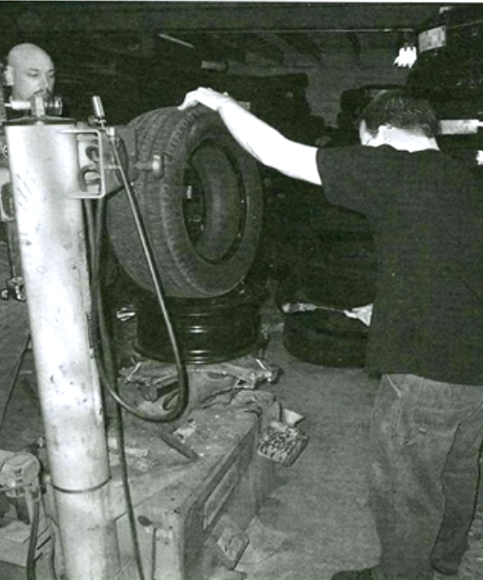
Example: A B C D 1) A B C D
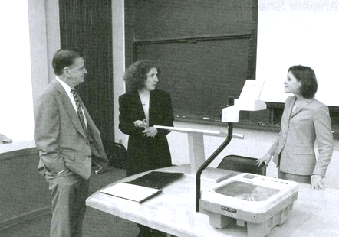

2) A B C D 3) A B C D
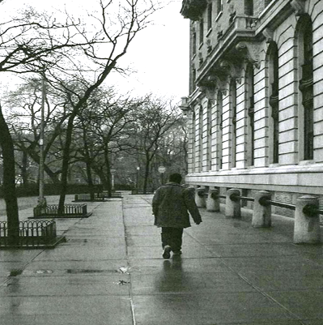
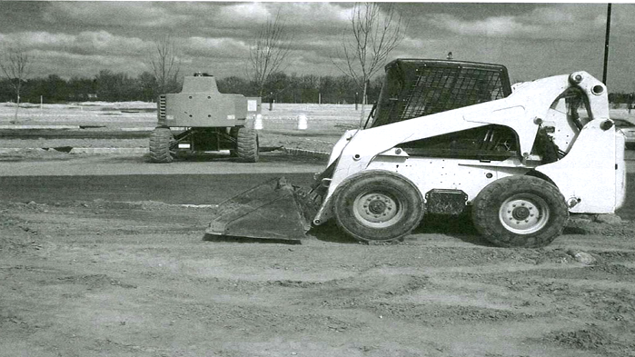

4) A B C D 5) A B C D

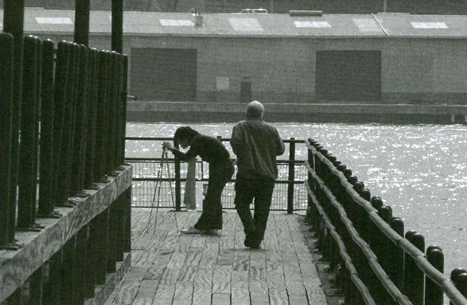
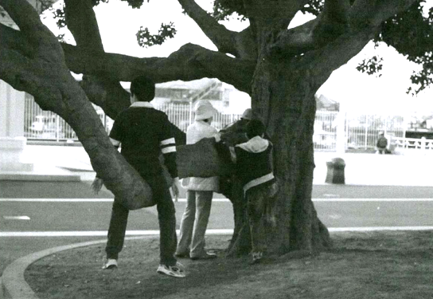

PART 2

11) A B C 12) A B C 13) A B C
14) A B C 15) A B C 16) A B C
17) A B C 18) A B C 19) A B C
20) A B C 21) A B C 22) A B C
23) A B C 24) A B C 25) A B C

PART 3

CONVERSATION 1
41) When does the conversation take place?
A. In the morning
B. Around midday
C. In the late afternoon
D. At night
42) What are the speakers waiting for?
A. A call from a customer
B. A job application
C. A food delivery
D. A contract
43) What does the woman suggest?
A. Sending a fax
B. Making a phone call
C. Hiring a new manager
D. Flying to Seoul

CONVERSATION 2
44) What has the woman just done?
A. Returned from vacation
B. Made a dinner reservation
C. Read an interesting book
D. Bought some house plants
45) Why does the woman thank the man?
A. He sent her a postcard.
B. He took care of her plants.
C. He arranged her hotel accommodation.
D. He painted her house.
46) What does the man give the woman?
A. A key
B. A hiking map
C. Some newspapers
D. Some water

CONVERSATION 3
47) When does the last interview start?
A. At 9:00
B. At 10:00
C. At 11:00
D. At 12:00
48) Who is the man planning to visit this afternoon?
A. A client
B. A job applicant
C. A relative
D. A doctor
49) Why might the woman make a telephone call?
A. To arrange a job interview
B. To request some paperwork
C. To change a meeting time
D. To purchase some supplies

CONVERSATION 4
50) What is the problem with the party?
A. The weather is bad.
B. There is a shortage of food.
C. Space is limited.
D. There is a scheduling conflict.
51) Why is the party being held for Maria?
A. She received a promotion.
B. She is retiring.
C. She is relocating.
D. She is getting married.
52) Where was the party originally scheduled to take place?
A. In a restaurant
B. In a conference room
C. In a garden
D. In an apartment

CONVERSATION 5
53) What are the speakers discussing?
A. A hiking trip
B. A hiring decision
C. A train schedule
D. A local restaurant
54) How long ago did the man visit the place being discuss?
A. Two days ago
B. Two weeks ago
C. Two months ago
D. Two years ago
55) How will the speakers probably get to their destination?
A. By walking
B. By taking the train
C. By driving
D. By taking a bus

CONVERSATION 6
56) Where does this conversation take place?
A. At a hotel
B. At an office supplies store
C. At a train station
D. At a restaurant
57) What is the man looking for?
A. A hotel room
B. A briefcase
C. A folder
D. An article
58) What does the woman offer to do?
A. Pay for breakfast
B. Look for a lost item
C. Organise a training session
D. Write a magazine article

GRAMMAR

Part One
Incomplete sentences (12 questions)
Circle the correct answer

1. _________ of the meeting he was very tired.

(A) In the end
(B) At the end
(C) On the end
(D) To the end

2. I’ve decided to _____________ a job in southern California.

(A) postulate
(B) application
(C) apply for
(D) candidate for

3. We think a lot of the capital for our business expansion could be __________ from our major suppliers.

(A) risen
(B) rose
(C) arisen
(D) raised

4. Our stocks of the Judy line product are very _______—we need to get some more in.

(A) low
(B) bottom
(C) under
(D) deep

5. He suggested ________________ an earlier flight.

(A) us to take
(B) us take
(C) we take
(D) to us take

6. If by any chance sales dropped by more than 15%, we _________________ closing down the product’s development altogether.

(A) had to consider
(B) would have to consider
(C) would have had to consider
(D) would had to consider

7. 2001 was not the first year in which the company’s turnover grew by more than 5%. In 1995, we ______________ 7%.

(A) had had
(B) have had
(C) had have
(D) have known

8. The task I gave you is really not so complicated. I really don’t understand why you keep ___________ it off.

(A) writing
(B) pushing
(C) delaying
(D) putting

9. One reason why food prices have gone up significantly in recent years is simply a question of relative __________ and demand.

(A) offer
(B) provide
(C) provision
(D) supply

10. Can we _____________ this later?

(A) discuss
(B) discuss about
(C) discuss over
(D) discuss on
11. Mr. Aylesworth? No I’m sorry sir, he’s not _____________ at this time. Can he call you back?

(A) available
(B) joinable
(C) to speak
(D) presence

12. I don’t see the connection at all. Why should my working late _______________________?

(A) be anything to see with it
(B) have to do with it
(C) have anything to do with it
(D) have anything to see

Part Two
Identify the mistakes in the following sentences. (13 questions)
1. There is two cars over there.
A. There B. is
C. two D. there
2. The earth is the only planet with a large number of oxygen in its atmosphere.
A. The B. number
C. oxygen D. its

3. A painter who lived most of his life in the Middle West, Grant wood has called America's Painter of the Soil.
A. most B. his life
C. has called D. Painter of the Soil

4. Three months after they have been laid, crocodile eggs are ready hatched.
A. laid B. crocodile
C. ready D. hatched

5. Peas require rich soil, constant moistures, and a cool growing season to develop well.
A. rich B. moistures
C. growing D. well

6. A rabbit moves about by hopping on its hind legs, which are much longer and more strong than its front legs.
A. moves about B. hopping
C. which are D. more strong
7. During the Middle Ages, handwriting notices kept groups of nobles informed of important events
A. During B. handwriting
C. kept D. informed of

8. I enjoyed study geography at school and now I’ve enrolled at the Economics Faculty.
A. I enjoyed B. study geography
C. I’ve enrolled D. the Economics faculty

9. I used to be keen of all scientific subjects but now I would prefer to study art.
A. I used to B. keen of
C. scientific subjects D. I would prefer

10. I want meet your sister when she comes to see you – she sounds very nice.
A. I want meet B. when she comes
C. she D. very nice

11. The tickets, which are extremely good value, can be buy from large supermarkets.
A. which B. good value
C. can be buy D. large supermarkets

12. He wanted always to be a doctor and after doing medicine he now works in a hospital

A. wanted always B. a doctor
C. after doing D. works

13. The informations they gave us was not very helpful so I consulted the website instead.
A. informations B. gave us
C. helpful D. so

READING
Question 1


1. What is the purpose of this advertisement?
(A) To announce a change in business hours
(B) To advertise a business for sale
(C) To encourage diners to eat early
(D) To attract more customers

2 What will customers receive if they spend more than $10?
(A) A $2 discount on their bill
(B) 50% off their next purchase
(C) A liter of soda
(D) Free delivery service

3. What will happen on June 16?
(A) A new owner will take over the business.
(B) The coupons will expire.
(C) Prices will be further reduced.
(D) The business will close.

Question 2
The new economy has created great business opportunities as well as great turmoil. Not since the Industrial Revolution have the stakes of dealing with change been so high. Most traditional organizations have accepted, in theory at least, that they must make major changes. Even large new companies recognize that they need to manage the changes associated with rapid entrepreneurial growth. Despite some individual successes, however, this remains difficult, and few companies manage the process as well as they would like. Most companies have begun by installing new technology, downsizing, restructuring, or trying to change corporate culture, and most have had low success rates. About 70 percent of all change initiatives fail.
The reason for most of these failures is that in their rush to change their organizations, managers become mesmerized by all the different, and sometimes conflicting, advice they receive about why companies should change, what they should try to accomplish, and how they should do it. The result is that they lose focus and fail to consider what would work best for their own company. To improve the odds of success, it is imperative that executives understand the nature and process of corporate change much better.
Most companies use a mix of both hard and soft change strategies. Hard change results in drastic layoffs, downsizing, and restructuring. Soft change is based on internal organizational changes and the gradual development of a new corporate culture through individual and organization learning. Both strategies may be successful, but it is difficult to combine them effectively. Companies that are able to do this can reap significant payoffs in productivity and profitability.

4. What is the article mainly about?
(A) Corporate marketing plans
(B) New developments in technology
(C) Ways for companies to increase profits
(D) How companies try to adapt to new conditions

5. The word “manage” in paragraph 1, line 6, is closest in meaning to
(A) correct
(B) attract
(C) handle
(D) regulate

6. According to the article, why do so many attempts to change fail?
(A) Soft change and hard change are different.
(B) Executives are interested only in profits.
(C) The best methods are often not clear.
(D) Employees usually resist change.

7. What is soft change based on?
(A) Changes in the corporate culture
(B) Reductions in company size
(C) Relocating businesses
(D) Financial markets
Question 3

Are you setting up a small business? Worried about the costs of renting office space and employing the right people?
Rebus Virtual Office World can help you. With our Basic Office Deal, we can set up a virtual office for you practically overnight.
We will give your business a professional image and our polite, friendly staff will handle your calls and present your business in the best possible way. We can provide you with: a professional business address, a local phone number and we will also handle mail.
For a more personal approach, with the option of forwarding mail and messages to your home address, don’t hesitate to ask us about our Premier Office Deals.

8. Where is the text from?
A) A message from a business to a current client
B) An advertisement for a new business service
C) An email from one business worker to another
D) A newspaper article about a new business’s success
9. What does the service provide?
A) Off-site staff to perform general office duties.
B) A site where several businesses can locate their offices
C) Advice on how to make your business more professional
D) Temporary staff for local businesses
10. Which of the following is not included in the Basic Office deal?
A) A polite receptionist
B) A mail-forwarding service
C) A professional address
D) A telephone-answering service

WRITING
Write an essay based on the following question (300-350 words). You have 30 minutes to plan, write and revise your essay. Underline your thesis statement.
Many companies now allow employees to work from home instead of going to an office every day. Some people think remote work improves productivity and work-life balance, while others believe that working in an office is better for teamwork and motivation.
Do you think employees should be encouraged to work from home or go to the office? Give reasons and examples to support your opinion.

