Section 1: Listening
Part 1 (Photographs) - https://www.youtube.com/watch?v=q4PjYnW_Ad4&t=77s

- A B C D 2. A B C D
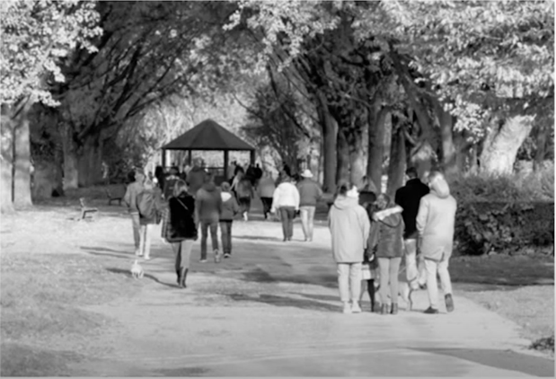

- A B C D 4. A B C D
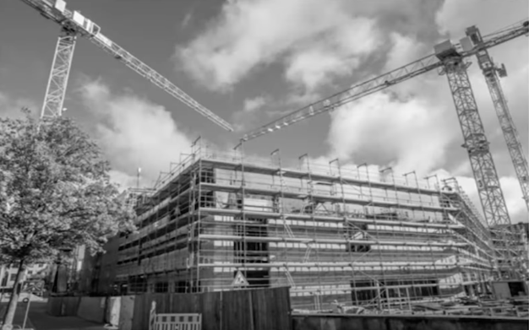

5. A B C D 6. A B C D
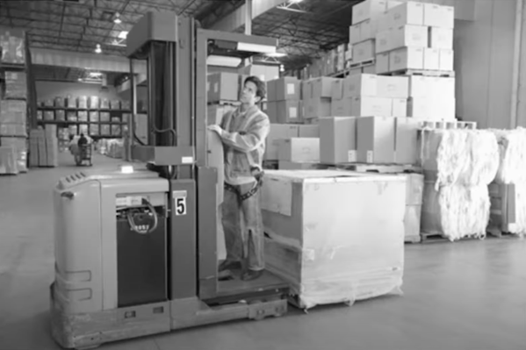

Part 2 (Question-Response)

7. A B C
8. A B C
9. A B C
10. A B C
11. A B C
12. A B C
13. A B C
14. A B C
15. A B C
16. A B C
17. A B C
18. A B C
19. A B C
20. A B C
21. A B C
22. A B C
23. A B C
24. A B C
25. A B C
26. A B C
27. A B C
28. A B C
29. A B C
30. A B C
31. A B C

Part 3 (Conversations) - https://www.youtube.com/watch?v=jjpFWTrhCRk

Conversation 1 (Q32-34)

32. Where does the conversation probably take place?
A) At a farm
B) At a restaurant
C) At a grocery store
D) At a post office

33. What does the woman say about the shipment?
A) It has been delayed
B) It is important from a foreign country
C) It has been small
D) It has been damaged

34. What is the man making?
A) A multi-grain bread
B) A vegetable soup
C) A fruit pie
D) A mixed salad

Conversation 2 (Q35-37)

35. Why is Mr Takeshi out of the office?
A) He’s on a business trip
B) He’s on a vacation
C) He’s working in a hospital
D) He was in an accident

36. How long will Mr Takeshi be away from work?
A) One week
B) Two weeks
C) Three weeks
D) One month

37. What does the woman suggest doing?
A) Visiting him at his house
B) Paying him some money
C) Delivering him some documents
D) Seeing him at the hospital

Conversation 3 (Q38-40)

38. Who most likely is the man?
A) A potential client
B) A new employee
C) A technical consultant
D) A pharmacist

39. What did the woman send in advance?
A) A meeting agenda
B) Directions to the company
C) Her account information
D) Some paperwork

40. What is the man asked to show?
A) Photo identification
B) A revised contract
C) A confirmation email
D) A work portfolio

Conversation 4 (Q41-43)

41. What are the speakers discussing?
A) A play
B) A novel
C) A lecture
D) A concert

42. What do the speakers say about Emily Johnson?
A) She played different roles in a movie
B) She published a new book
C) She has won prizes before
D) She likes many actors

43. What do the speakers agree with?
A) They’re going to watch the movie together
B) They’re waiting for a new novel by Emily Johnson
C) They both liked the story by Emily Johnson
D) They don’t want the story to be made into a film

Conversation 5 (Q44-46)

44. What are the speakers doing?
A) Delivering computers
B) Installing software
C) Assembling office furniture
D) Preparing musical instruments

45. What does the woman suggest
A) Starting early tomorrow
B) Taking a break
C) Meeting with her brother
D) Working late tonight

46. What does the man plan to do in the evening?
A) Visit his brother from out of town
B) Go to a company banquet
C) Check the inventory in the warehouse
D) Attend a musical performance

Conversation 6 (Q47-49)

47. What are the speakers discussing?
A) Booking a flight
B) Signing up for a lecture
C) Shipping some items
D) Updating a website

48. What is the problem?
A) A phone number is not listed in the directory
B) A website is not working properly
C) The marketing team has few staff members
D) An email address is incorrect

49. What does the man offer to do?
A) Register for the seminar
B) Have the pamphlet delivered
C) Call some clients
D) Send the woman some information

Conversation 7 (Q50-52)

50. What is the woman’s problem?
A) Her printer was jammed
B) The service was too slow at the restaurant
C) The online connection needs to be updated
D) Her computer doesn’t work properly

51. What is NOT the reason the man recommended High-Tech Electronics?
A) They have a wide selection of products
B) Their prices are reasonable
C) They deliver for a fee
D) Their employees are kind and happy to help

52. What does the woman mean when she says “I need to do some research”?
A) She has a degree in science research
B) She needs to find some discount information
C) She wants to learn more about computer software
D) She needs more information before making a purchase

Section 2: Grammar

Part 1: Choose the correct answer (A, B, C or D) to fill in the gap.

- Financial advisors report that older investors tend to be ___________than their younger counterparts.
- Cautious
- Cautioned
- More cautious
- Caution

- Because of ________ fuel costs, some people are choosing to stay home for the summer vacation rather than drive to tourist sites.
- Rising
- Above
- Dependable
- Lengthy

- All the members have arrived __________________ Mr Peters.
- Accept
- Not
- Expect
- Except

- The restaurant has a ______________ decorated room that is perfect for hosting children’s parties.
- Cheerful
- Cheerfully
- Cheerfulness
- Cheer

- MyHealth Company has produced a wide range of vitamin supplements for
_____________ two decades.
- Along
- During
- Over
- When

- Taking risks is routine in our business, so we _______________.
- Used to it
- Used to do it
- Are used to it
- Are used

- ________________ the building has an excellent location and a modern interior; it is popular among visitors.
- In view of
- Provided that
- Other than
- Seeing that

- The green light on the side of the water purifier lights up ____________ the filter needs to be replaced.
- Likewise
- Whenever
- Therefore
- Whereas

- The donations received from the fundraiser ___________ among the charity’s three locations equally.
- Have divided
- Is being divided
- Are dividing
- Will be divided

- As we expect to receive hundreds of applications for the position, please ____________ your resume to two pages.
- Limit
- Follow
- Refrain
- Unfold

- The scenario that we are predicting _____________ an increased demand for our products.
- Should to create
- Should create
- Should creates
- Should creating

- Negotiation will take place __________________ London.
- At
- By
- In
- To

Part 2: Identify the error in the following sentences.

- The recently announcement about government incentives for foreign investments attracted the attention of the board.
- The recently
- About
- Foreign investments
- The attention of the board

- If you will finish the project early, please let me know so we can review it before the deadline.
- Will finish
- Let
- Can review
- Before

- Each of the employees are required to completed this training session before they can use the new software installed in the office last week.
- Are required
- Can use
- Installed
- Last week

- This year, the company has invest heavily in research and development.
- This year
- Had invest
- Heavily
- Research

- If you don’t understand the question, you should ask the teacher to explain it more clearly before you will answer it.
- Don’t understand
- Should ask
- More clearly
- Will answer

- The IT team is working on fixing the issue, but they haven’t found a solution still, so the system remains unavailable.
- Is working
- Haven’t found
- Still
- Unavailable

- My friends and I are planning to go to the beach this weekend, but it depends of the weather.
- And I
- To go
- This weekend
- Depends of

- The new policy requires all employees to submit their expense reports no later then the last day of the month to receive reimbursement.
- Requires
- To submit
- No later then
- To receive

- I was late to the meeting because my car broke out on the way and I had to call a mechanic to look into the problem and fix it as soon as possible before I could continue my journey.
- To the meeting
- Broke out
- Look into
- Could continue

- A number of customers has complained about the slow service, so the company is working on improving its response time.
- Has complained
- Slow
- Is working
- Its response time

- Today’s traffic was the worse I have ever seen – it took me longer to get home than usual because there were more accidents on the highway than expected.
- The worse
- Longer
- More accidents
- Than expected

- The manager gave us an important advice about how to handle customer complaints more effectively during the training session at the office in New York last week.
- An important advice
- More effectively
- In New York
- Last week

- I was reading the report when I have received an important email from the client and I immediately replied to it.
- Was reading
- Have received
- From the client
- Replied

Section 3: Reading Comprehension

Text 1:
This Amazing World Photography Competition
The monthly travel magazine This Amazing World is offering a discounted subscription rate for those who sign up during the month of November. This Amazing World has been in print for over 30 years and offers readers insider tips and expert know-how to help you plan the vacation of your dreams.
The magazine includes vacation package advertisements, reviews from travellers, and insightful essays to introduce you to various cultures, cuisines, and travel destinations.
Submit your travel photos to our This Amazing World Photography Competition for a chance to win a fantastic vacation to Scotland! The winner of the top prize will receive round-trip tickets and a $2,000 travel voucher for a hotel stay for two people.
- What is the purpose of the article?
- To promote a new travel agency
- To promote a travel photography contest
- To provide travel tips for Scotland
- To see photography equipment

- How long has the magazine existed for?
- 10 years
- 20 years
- 30 years
- 50 years

- What is one benefit of subscribing in November?
- A free trip to Scotland
- A chance to submit photos for the contest
- A lower subscription price
- A free photography lesson

- What does the winner of the competition receive?
- A photography magazine subscription
- A guided tour of Europe
- Free travel tickets and a hotel voucher
- A photography job offer

- What kind of content does This Amazing World magazine NOT include?
- Cooking recipes
- Travel package ads
- Cultural essays
- Traveller tips

Text 2: Read the email and answer the questions.
Velon Refrigerators s. A.
323 Via Da Costa,
Sao Paolo, Brazil
Tel: (40) 77211
Website: http://www.cosmo.br
May 13
Ms. Karen Woodward, Executive Manager Higham Industries
150 Towns Road
Chicago, IL 60601
U.S.A.
Dear Ms. Woodward,
Thank you for your letter dated May 7 about a possible alliance between our two companies. We are quite excited at the proposal of teaming up on a project. We would like to discuss it with you further and welcome you to visit our office in Sao Paolo to discuss the matter in detail. Any time after May 30 will be fine with us.
One thing that needs to be addressed before we move forward is the price of the products you will provide. One of the priorities of our business has been marketing quality refrigerators at reasonable prices. If we can reach an acceptable price range, we would like to go ahead and sign a contract with you immediately. Please send us your ideas regarding this issue so that we can examine them prior to the meeting.
Sincerely yours,
Alejandro Zaralejos
Vice President

- What topic did Ms Woodward address in a previous letter?
- Purchasing Mr Zaralejo’s company
- Forming a partnership with Velon
- Launching a new line of refrigerators
- Relocating her company to Sao Paolo

- What will the two companies probably talk about next?
- Who will be in charge of the project
- When to put the new products on the market
- How much the products will cost
- What modification should be made in the contract

- What is one concern mentioned in the email?
- The location of the meeting
- The price of the products
- The quality of the refrigerators
- The size of the company

Text 3: Read the following 3 texts and answer the questions.
Come to Al’s Electronics for a Special Offer
You often hear the phrase “Out with the old and in with the new”. At Al’s Electronics, we believe in keeping the old along with the new. This weekend only, bring your old, broken radios, CD players, toasters, and any other electronics in to the store. If you bring it, we’ll fix it at absolutely no cost to you. We can repair TVs, laptops, and heaters as well. Each shopper can receive up to $50 worth of free repairs. All you need to do is make a nonrefundable purchase of $100 or more. So pay a visit to your garage, attic, or toolshed and search for that item you’ve been meaning to get repaired. Visit Al’s Electronics at 549 Vernon Avenue this Saturday or Sunday, May 7 and 8, and we’ll have it working for you in no time. Call 675-9303 for more information.
Al’s Electronics
549 Vernon Avenue
Pittsburgh, PA
675-9303

Date: May 8
Customer Name: Eric Simpson
Phone Number: 509-4485
Item Number | Description | Quantity | Price
685-5542 | 64 GB Thumb Drive | 2 | $12.00
054-1022 | Sidewinder Toaster (Model RT40) | 1 | $52.00
966-6854 | Pampas DVD Player (Model 600TE) | 1 | $65.00
N/A | Repair Work (Video Game Console) | 1 | $0.00
 |  | Subtotal | $129.00
 |  | Tax | $6.45
 |  | Total | $135.45

NOTES: Repair work done by Jason Hampton
Thank you for shopping at Al’s Electronics. We hope you come again soon.

May 10
To Whom It May Concern,
My name is Eric Simpson. On the 8th of May, I visited your store and made a couple of purchases. I took advantage of the chance to have my old video game console repaired while I was there. I must say that the person who fixed the machine did an outstanding job. The machine hadn't worked for more than a decade, but it runs perfectly now. My younger brother and I have been having a great time playing video games from the 1990s for the past couple of days. Please be sure to thank the person who did the repair work. I can't recall his name, but I know he is one of the managers there. I've got an old tape recorder that's in pretty poor shape. I'm probably going to visit in the next week to have it fixed. I realize that will cost money, but I would like to listen to some of my old tapes, so I don't mind paying a fee.
Your faithfully,
Eric Simpson

9) What kind of offer is being advertised?
A) An opportunity to get a free service
B) A discount on selected items
C) A chance to exchange old items for new ones
D) A free consultation regarding purchases

10) What is mentioned about the offer?
A) It is not applied to some types of items
B) It will last for the entire month of May
C) It requires shoppers to make a purchase
D) It is only being offered to members

11) What is suggested on the invoice?
A) Mr Simpson can exchange the items he bought
B) The toaster was purchased at a discounted price
C) A shipping fee was charged to deliver the items
D) The repairs on the video game console were worth less than $50

12) Why did Mr Simpson write the letter?
A) To ask about getting an item he owns repaired
B) To express his pleasure with the service he received
C) To find out how his video game console was fixed
D) To complain about the quality of some repairs

13) What does Mr Simpson indicate about Al’s electronics?
A) It will have another special sale soon
B) It employs Jason Hampton as a manager
C) It was unable to repair his tape recorder
D) It overcharged him for an item he bought

Section 3: Grammar

Part 1: Choose the correct answer (A, B, C or D) to fill in the gap.

- Financial advisors report that older investors tend to be ___________than their younger counterparts.
- Cautious
- Cautioned
- More cautious
- Caution

- Because of ________ fuel costs, some people are choosing to stay home for the summer vacation rather than drive to tourist sites.
- Rising
- Above
- Dependable
- Lengthy

- All the members have arrived __________________ Mr Peters.
- Accept
- Not
- Expect
- Except

- The restaurant has a ______________ decorated room that is perfect for hosting children’s parties.
- Cheerful
- Cheerfully
- Cheerfulness
- Cheer

- MyHealth Company has produced a wide range of vitamin supplements for
_____________ two decades.
- Along
- During
- Over
- When

- Taking risks is routine in our business, so we _______________.
- Used to it
- Used to do it
- Are used to it
- Are used

- ________________ the building has an excellent location and a modern interior; it is popular among visitors.
- In view of
- Provided that
- Other than
- Seeing that

- The green light on the side of the water purifier lights up ____________ the filter needs to be replaced.
- Likewise
- Whenever
- Therefore
- Whereas

- The donations received from the fundraiser ___________ among the charity’s three locations equally.
- Have divided
- Is being divided
- Are dividing
- Will be divided

- As we expect to receive hundreds of applications for the position, please ____________ your resume to two pages.
- Limit
- Follow
- Refrain
- Unfold

- The scenario that we are predicting _____________ an increased demand for our products.
- Should to create
- Should create
- Should creates
- Should creating

- Negotiation will take place __________________ London.
- At
- By
- In
- To

Part 2: Identify the error in the following sentences.

- The recently announcement about government incentives for foreign investments attracted the attention of the board.
- The recently
- About
- Foreign investments
- The attention of the board

- If you will finish the project early, please let me know so we can review it before the deadline.
- Will finish
- Let
- Can review
- Before

- Each of the employees are required to completed this training session before they can use the new software installed in the office last week.
- Are required
- Can use
- Installed
- Last week

- This year, the company has invest heavily in research and development.
- This year
- Had invest
- Heavily
- Research
- If you don’t understand the question, you should ask the teacher to explain it more clearly before you will answer it.
- Don’t understand
- Should ask
- More clearly
- Will answer

- The IT team is working on fixing the issue, but they haven’t found a solution still, so the system remains unavailable.
- Is working
- Haven’t found
- Still
- Unavailable

- My friends and I are planning to go to the beach this weekend, but it depends of the weather.
- And I
- To go
- This weekend
- Depends of

- The new policy requires all employees to submit their expense reports no later then the last day of the month to receive reimbursement.
- Requires
- To submit
- No later then
- To receive

- I was late to the meeting because my car broke out on the way and I had to call a mechanic to look into the problem and fix it as soon as possible before I could continue my journey.
- To the meeting
- Broke out
- Look into
- Could continue

- A number of customers has complained about the slow service, so the company is working on improving its response time.
- Has complained
- Slow
- Is working
- Its response time

- Today’s traffic was the worse I have ever seen – it took me longer to get home than usual because there were more accidents on the highway than expected.
- The worse
- Longer
- More accidents
- Than expected

- The manager gave us an important advice about how to handle customer complaints more effectively during the training session at the office in New York last week.
- An important advice
- More effectively
- In New York
- Last week

- I was reading the report when I have received an important email from the client and I immediately replied to it.
- Was reading
- Have received
- From the client
- Replied

Section 4: Writing

Some people prefer shopping online, while others enjoy going to physical stores.

Which do you prefer: online shopping or shopping in stores? Explain your opinion with examples.

_________________________________________________________________________________________________________________________________________________________________________________________________________________________________________________________________________________________________________________________________________________________________________________________________________________________________________________________________________________________________________________________________________________________________________________________________________________________________________________________________________________________________________________________________________________________________________________________________________________________________________________________________________________________________________________________________________________________________________________________________________________________________________________________________________________________________________________________________________________________________________________________________________________________________________________________________________________________________________________________________________________________________________________________________________________________________________________________________________________________________________________________________________________________________________________________________________________________________________________________________________________________________________________________________________________________________________________________________________________________________________________________________________________________________________________________________________________________________________________________________________________________________________________________________________________________________________
______________________________________________________________________________________________________________________________________________________

