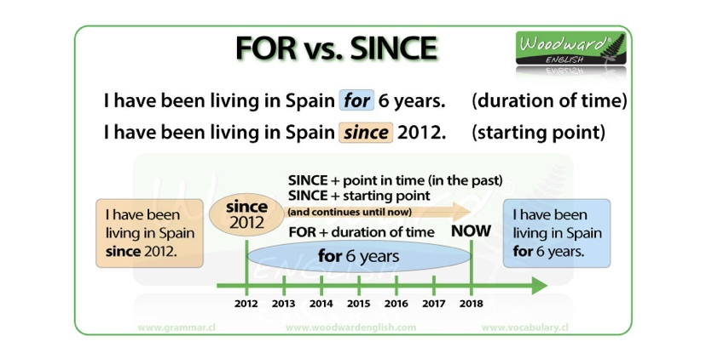

Exercise 1. Complete with FOR or SINCE.

1. -------------------10 o’clock.
2. -------------------- Christmas.
3. -------------------- ten minutes.
4. --------------------- the last lesson.
5. --------------------- ages.
6. ---------------------- I was a child.
7. ---------------------- I last saw her.
8. ---------------------- a decade.
9. ---------------------- the beginning of the term.
10. --------------------- I was given the go-ahead.

Exercise 2. Complete the sentences with FOR or SINCE and the correct form of the verb.

1. Our family ------------------------------ (live) in the Kansas --------------- 1997.
2. My father ------------------------------- (work) as an engineer ---------------------- we moved here.
3. My parents ---------------------------- (be divorced) -------------------- more than 5 years.
4. My sister ------------------------------ (know) her boyfriend --------------------- six years.
5. How long --------------------------------- - (wait / you) ? -------------------- half an hour.
6. I ------------------------------------- (see) my aunt -------------------- a long time.
7. My friend Margo ------------------------------- (write) two letters ------------------------- we met at summer camp.
8. My friend Tommy ----------------------------- (decide) to move to the south. I -------------------------- (talk) to him ------------------------- then.
9. I ---------------------------------------------- (try) to work on my maths ----------------- the past 2 hours.
10. ------------------------------------------------ -(you / ever / see) such a beautiful landscape ?

