CLASS 9
FOR
Traduire les élements en gras dans les phrases suivantes :

- The City of London has been the financial heart of Britain for centuries, and is home to countless historic sites, including saint paul’s cathedral, the Royal Exchange and the Tower of London.
_______________________________________________________________________________

- For thousands of years, tuberculosis ravaged European cities.

__________________________________________________________________________________

MEMO :

Outre le sens évident de "pour", for peut signifier :

1. Pendant
For est suivi d'une référence temporelle, le verbe est au preterit, il se traduit en français par un temps passé :
For decades, divorce courts assumed that young children needed their mothers for proper psychological development.
pendant des décennies, les tribunaux ont supposé que … (sous-entendu : ce n' est plus le cas aujourd'hui.

2. Depuis
For est suivi d'une référence temporelle, le verbe est au present perfect, il se traduit en français par un présent:
For years, women have campaigned to be treated equally with men.
Depuis des années, les femmes militent … (sous-entendu : c'est encore le cas aujourd'hui)

3. Car
Scientists didn't start seriously examining ageing processes until the 1960's. The task is huge, for ageing affects all of the body's organs, tissues and cells.
… La tâche est rude, car le vieillissement affecte tous les organes, tissus et cellules du corps

4. Il peut être obligatoire dans la construction de certains mots : wait for, except for, the need for , ...

5. For all = malgré
For all Europe's efforts to create a unique culture, it's destined to become a lot more like America."
Malgré les efforts de l'Europe pour créer une culture unique, elle est vouée à ressembler de plus en plus à l'Amerique.

EXERCICE
Traduire les passages en gras dans les phrases suivantes.

- Tattooing has been practiced for centuries in many cultures spread throughout the world.

- The Home Depot hackers took aim at 7,500 of the company’s self-checkout lanes. The software hid itself for five months, collecting data and transmitting it to an outside system.

- For all his experience in management and coaching, Chris Hughton is confronting a new challenge this season.

- For years, studies upon studies have shown how bad sleep weakens the immune system, impairs learning and memory, contributes to depression and other mood and mental disorders, as well as obesity, diabetes, cancer and an early death.
SINCE

Traduire les passages en gras dans phrases suivantes :

- México has been subjected, since the middle of the last century, to a process of fast urbanization.

- Supporters say the self-driving cars may one day be far safer than those with humans at the wheel, since the machinery won't drive distracted, drunk or drowsy.

MEMO :

Les différents sens de since sont :

1. Depuis
The historic division of the Labour Party - which has existed in its present form since the end of the Second World War persists
… qui existe sous sa forme actuelle depuis la fin de la Seconde Guerre Mondiale ...

2. Depuis que

I’ve grown up with father as a politician since I was six years old. I’ve always known it was something that I would be interested in one day.

Lorsque since signifie "depuis" ou "depuis que" il est suivi d'une expression temporelle, date ou point de référence non daté (since1984, since he left the firm ).

Dans ces deux cas, le temps utilisé est le present perfect (cf. « for » quand il signifie « depuis » )

3. Puisque, étant donné que, vu que

Only future generations will be able to calculate the full consequences of President Trump’s incredibly shortsighted approach to climate change, since it is they who will suffer the rising seas and crippling droughts that scientists say are inevitable unless the world brings fossil fuel emissions to heel.

Lorsque since signifie "étant donné que " assurez-vous que vous comprenez le raisonnement de la phrase.

Note :
Since then = depuis lors
The more so since = d'autant plus que

EXERCICE

Indiquer le sens de since dans chacune des phrases suivantes.

- Many teachers have a zero-tolerance policy when it comes to phones out during class, since they assume—most of the time correctly—that their students are using them to text friends or update their various social media sites.

- “Until around the 90s, parents were not expected to endlessly entertain and monitor their children in the same way they are today, so children had greater freedom to play independently,” explained the study’s author Dr John Day. “But since those children have become parents themselves, society has changed so there is a heightened feeling of responsibility for their children’s development.

- If we play the futuristic game of imagining what the world of tomorrow will be like, we think of a society given over to technology. Screens will be everywhere and tech tools will be used for everything. This is a logical projection, since these solutions already play a major role in our daily lives.

- Since the introduction of plastics in the mid-20th century, humans have created 8.3 billion tons of the stuff — nearly half of it made in the last two decades.
AS

Quel est le sens de « as » dans la phrase suivante ? et dans le cartoon ?
As a communicator, I want to be inclusive, so if I know that there is one single person in the audience who will not understand Maltese, I will give it in English.

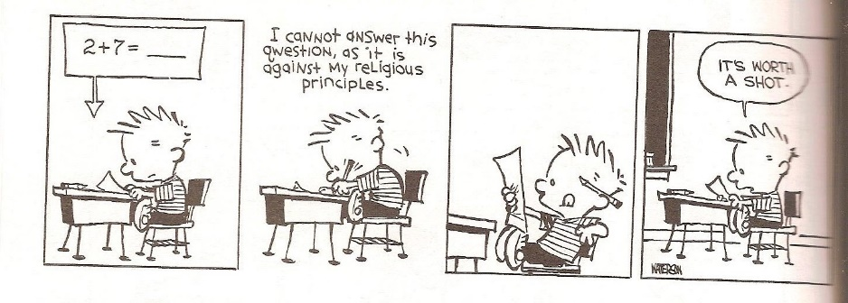
MEMO :
La plupart du temps, le mot « comme » est un équivalent acceptable de as . Toutefois, selon la valeur de as, et selon le contexte, remplacer as par « comme » ne convient pas toujours ou ne garantit pas une bonne compréhension de la phrase.

Les principaux sens de as sont :

1. Sens temporel : au moment où, pendant que, à mesure que
As people age, they need more time to recover from arduous activity.
A mesure que les gens vieillissent, il leur faut plus de temps pour se remettre d'une activité intense.
As she entered the room, every eye turned towards her.
Au moment où elle entra dans la pièce…

2. Puisque, étant donné que
As he had been up since 4 a.m., he was no doubt now very tired.
Etant donné qu'il était debout depuis 4 heures du matin, il était sans doute très fatigué à présent.

3. Comme (manière), ainsi que
As one of the characters in the movie says: “learning a foreign language rewires your brain”
Comme le dit un des personnages du film : …

4. En tant que
As Prime Minister in the early 1970s, sir Edward Heath negotiated Britain's admission to the European Community.
En tant que Premier Ministre ….

5. Comparatif d'égalité : aussi ... que
The meal was as awful as the conversation.
Le repas a été aussi médiocre que la conversation.

EXERCICE
Quel est le sens de "as" dans les phrases suivantes? (ne traduisez pas par « comme »)

- Before his election, Mr Biden had written that as president, he would focus on national issues first.
- As the climate warms, glaciers retreat and meltwater collects, forming lakes.
- Two captive raccoon dogs escaped their enclosure… The animals are potentially dangerous if approached as they are not domesticated.
- “We know that Australia on its own cannot control the world’s climate as Australia accounts for just 1.3% of global emissions,” Morrison said.
- South Australia is considering a plan to import and store nuclear waste above ground over the next 120 years. The plan could generate more than $51 billion in revenue for the state as it would be paid to store other countries’ nuclear waste. […] As could be expected, the public strongly opposes the plan.

